**1.Create a Kanban Board to Visualize the Tasks.**

**∙ Create Columns for To Do, In-Progress and Done.**

**∙ Add Atleast 5 Sample Tasks**

**∙ Move the Tasks across the Columns to Simulate the Workflow**

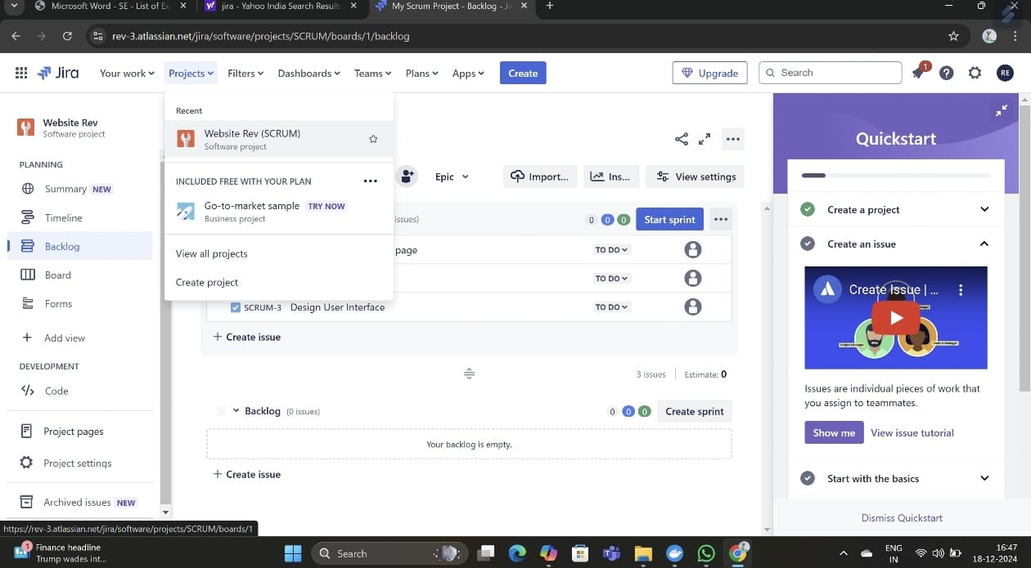

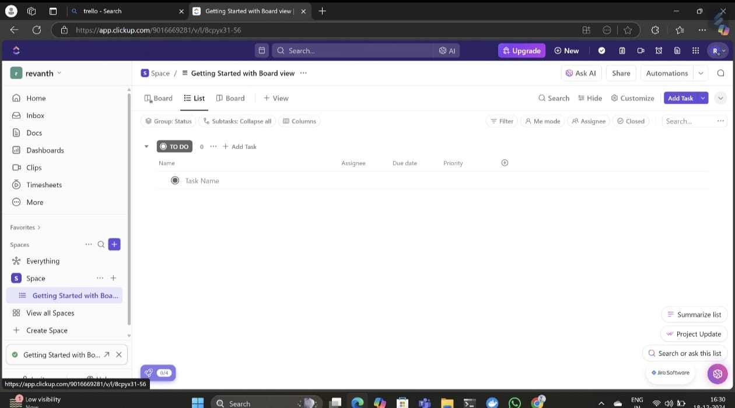

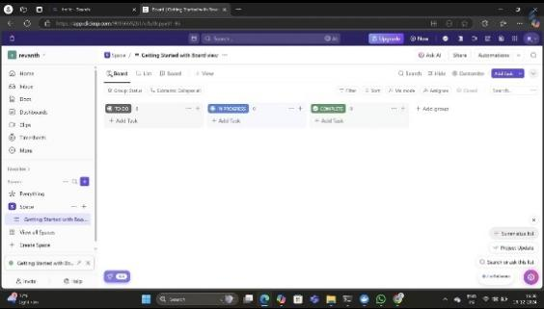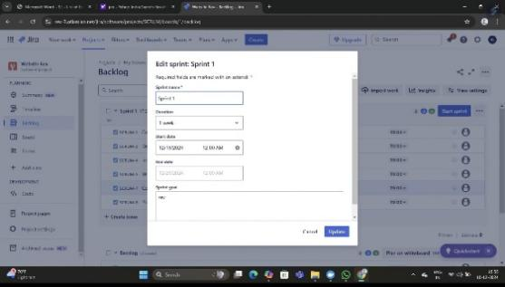

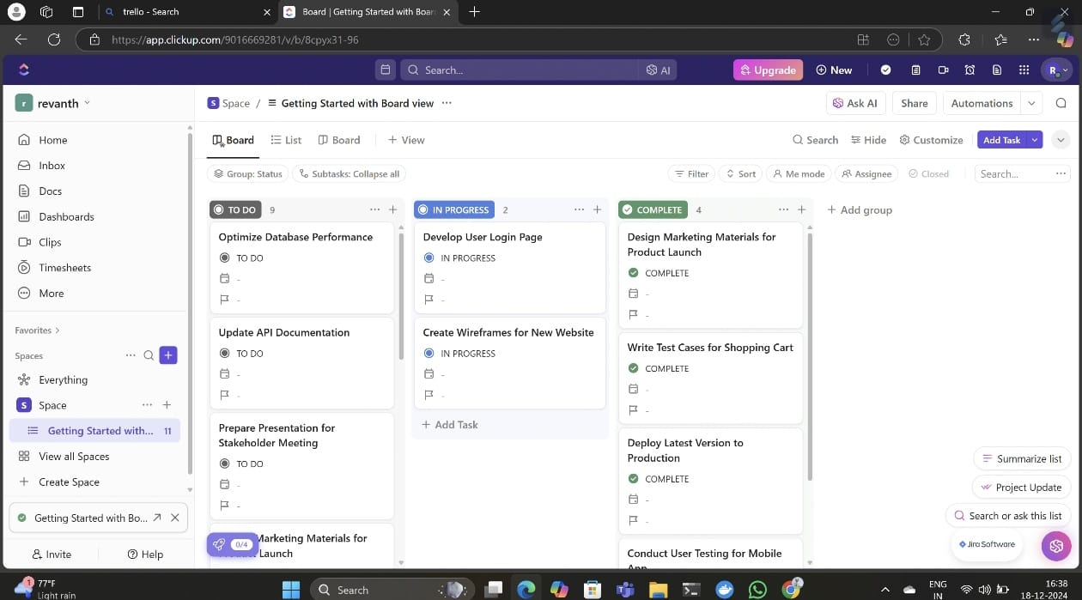

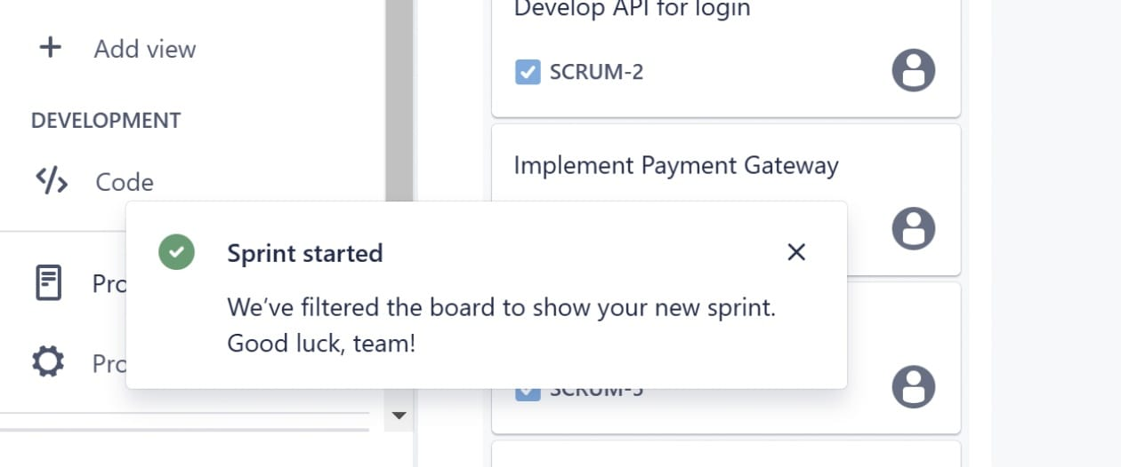**.**

**2.Sketch a Simple Prototype of a Bus Ticket Booking System using**

**Figma Tool.**

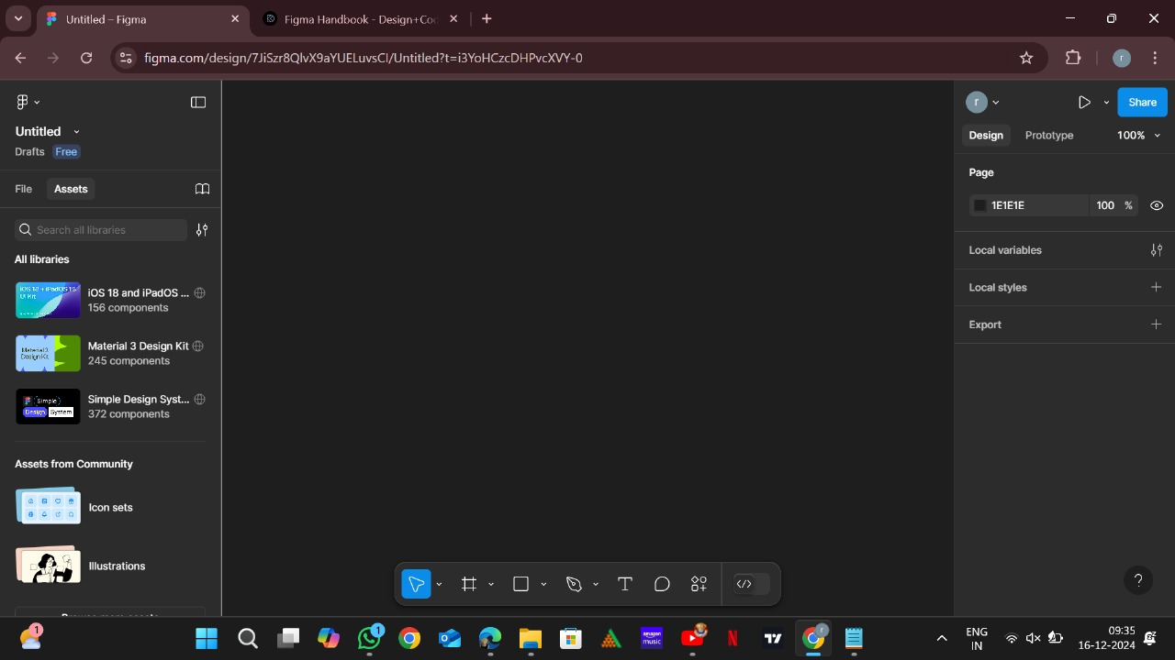

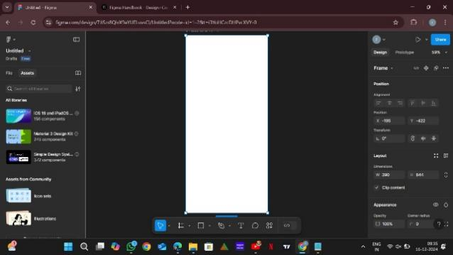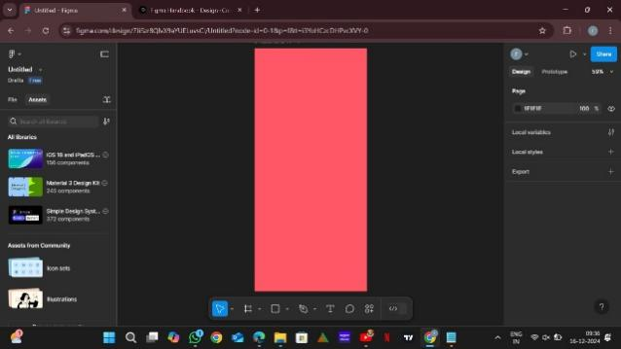

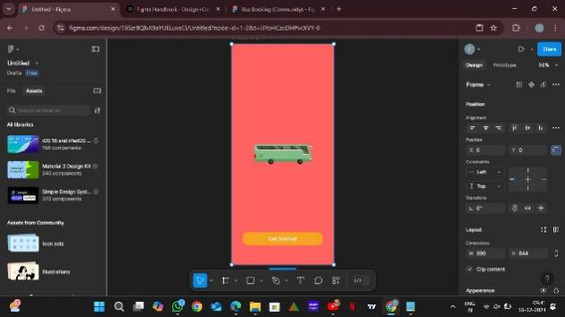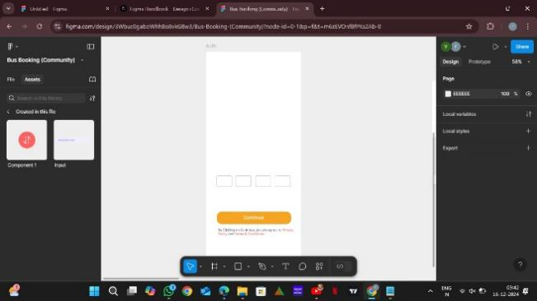

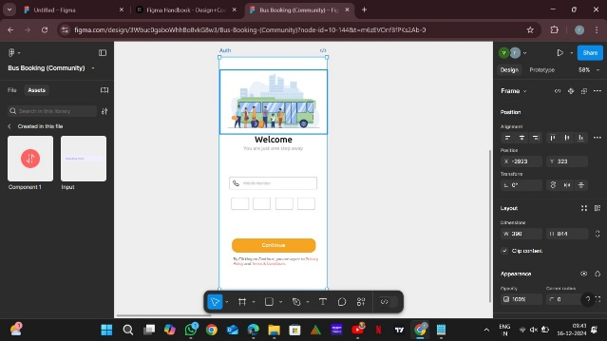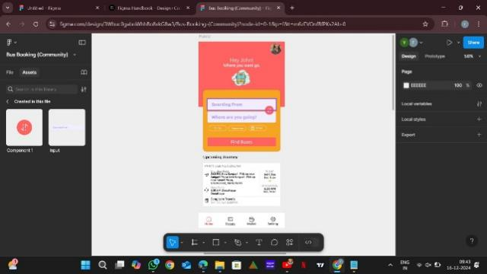

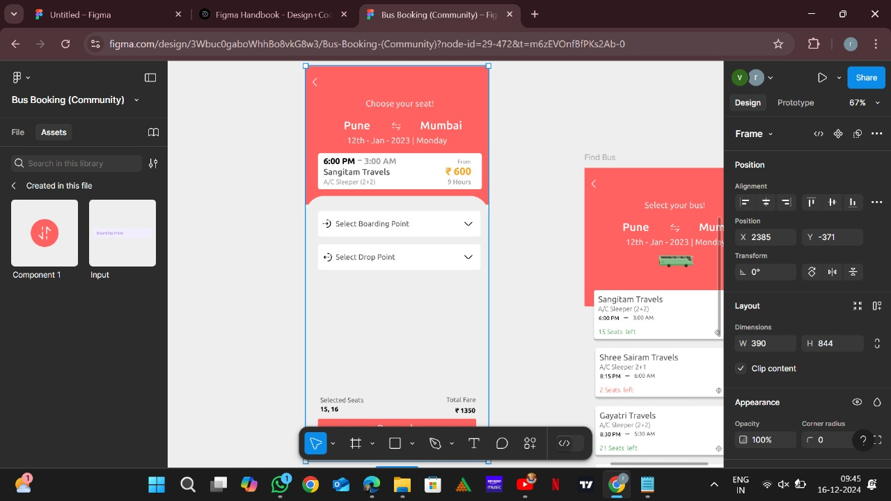

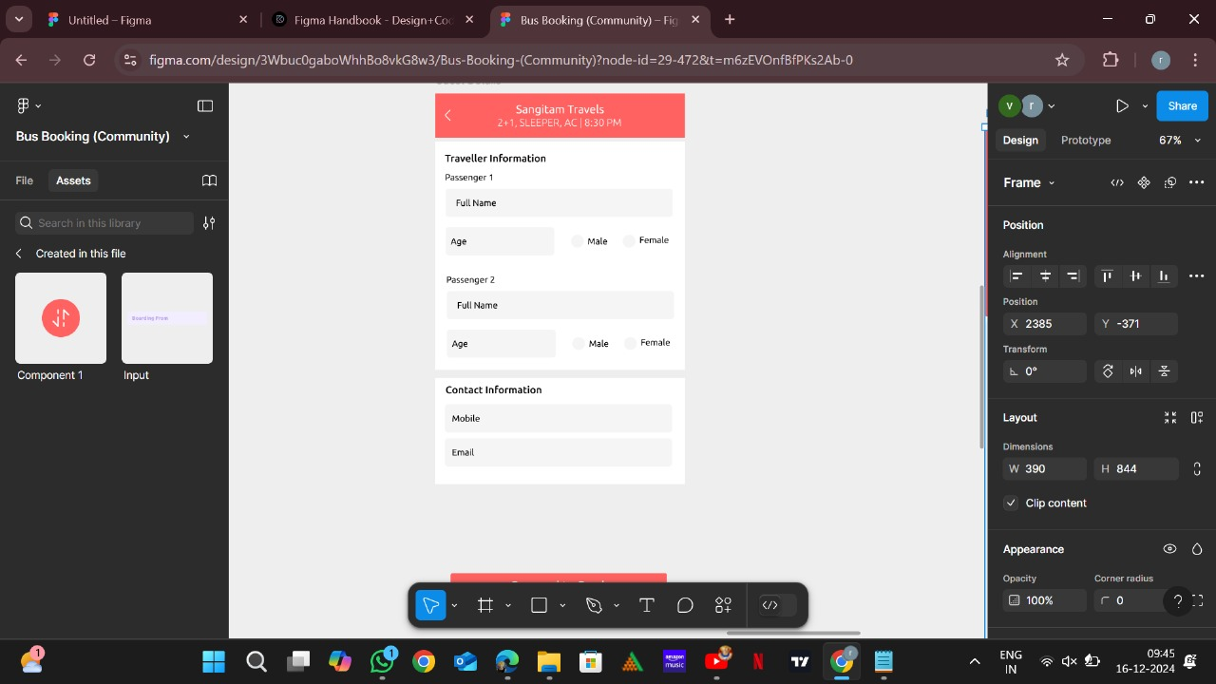

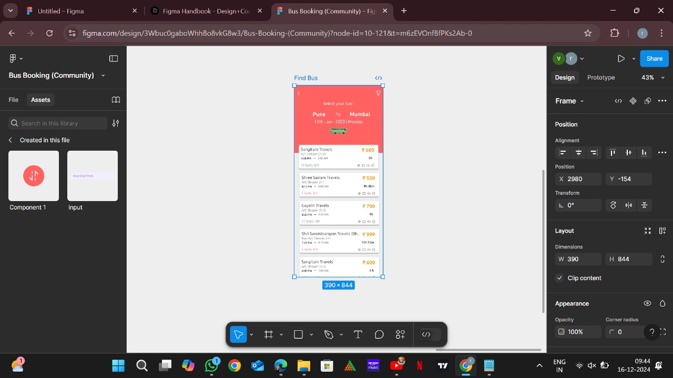

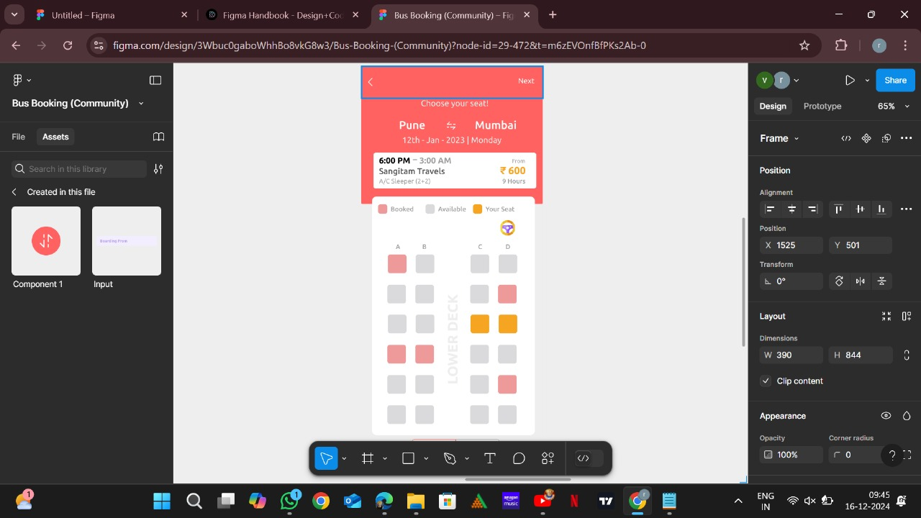

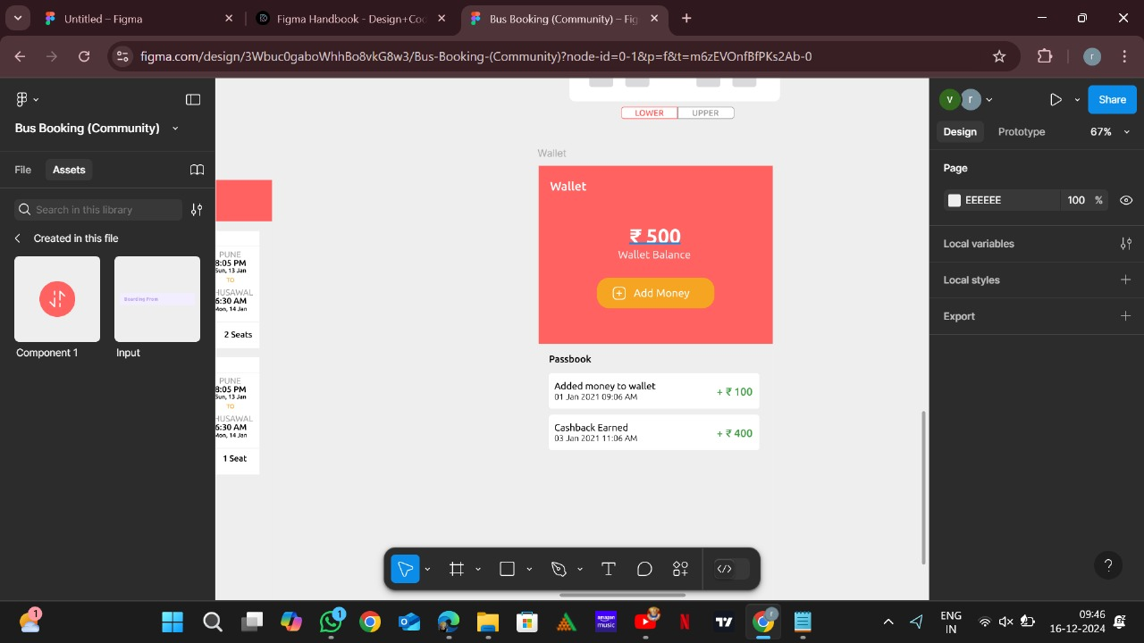

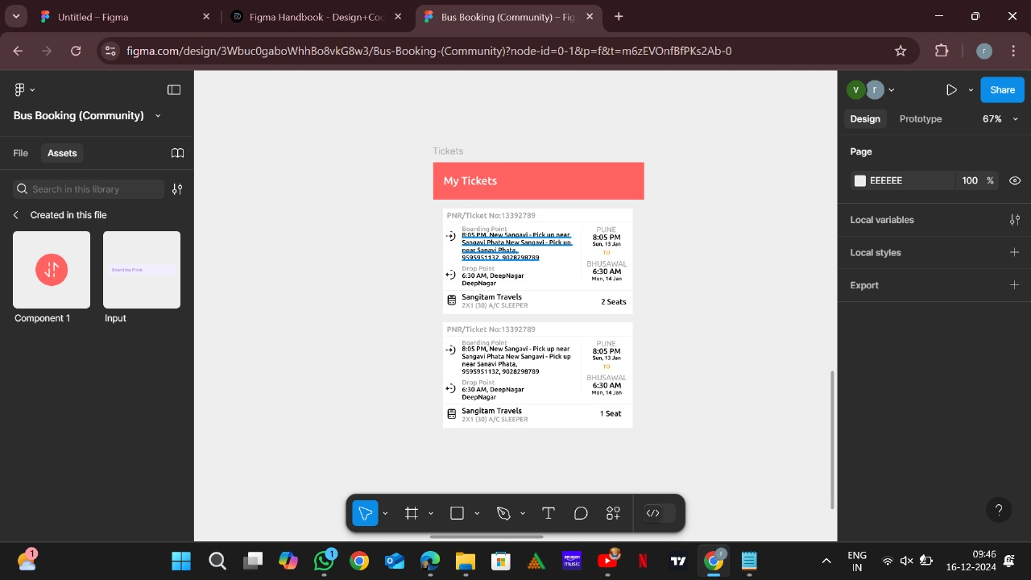

**End.**

**3.The stakeholders have conflicting views on the user interface design**

**for an E-Commerce mobile app. Create a prototype using Figma tool**

**to discuss with the stakeholders to get their feedback and approval.**



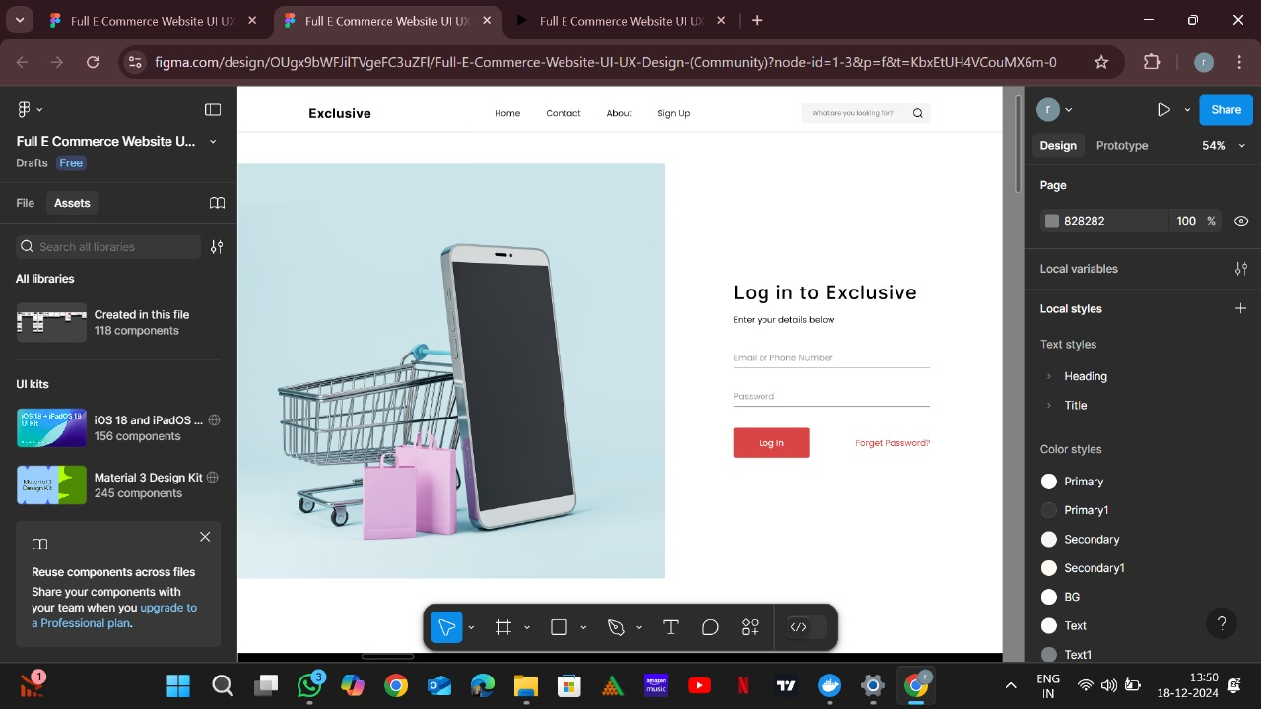

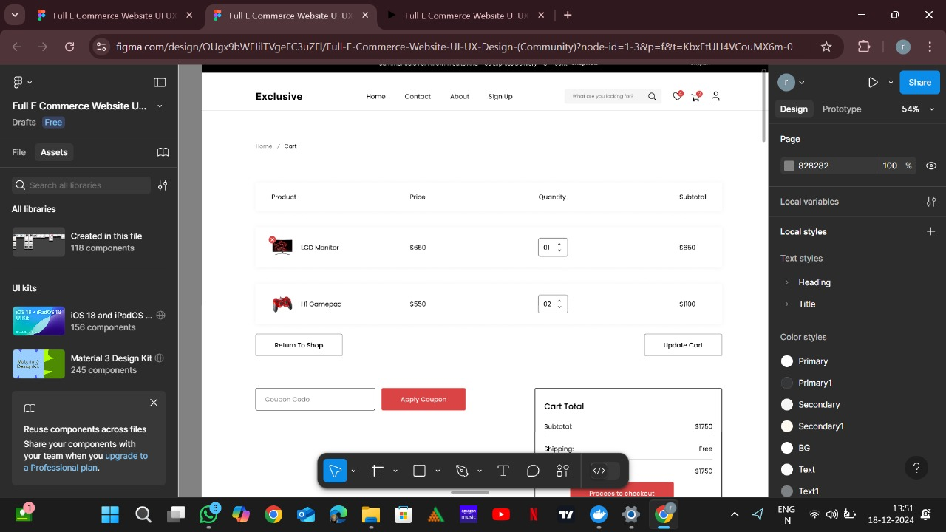

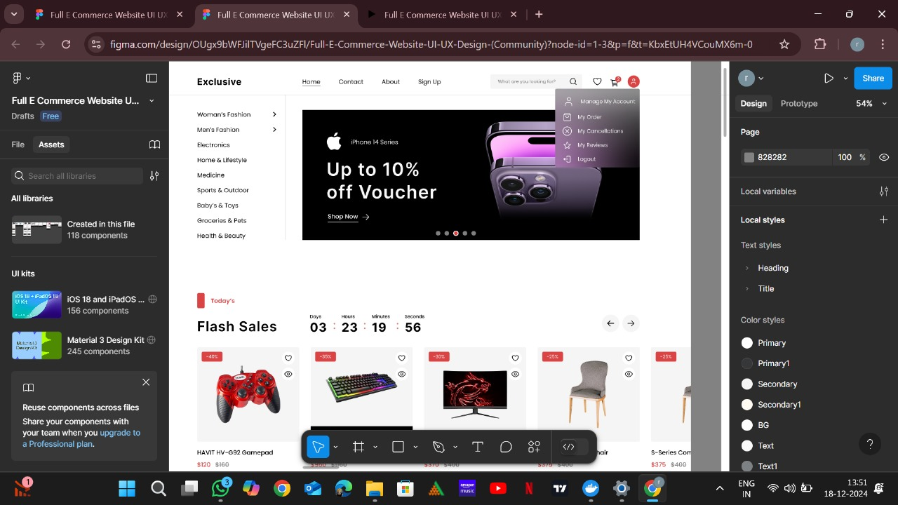

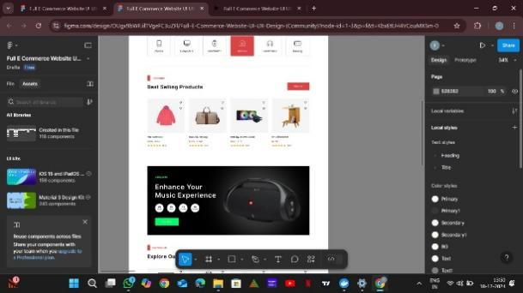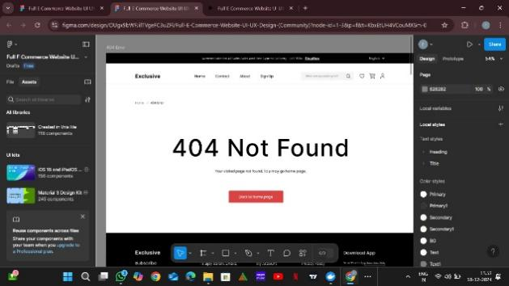

**End.**

**4.Create a Scrum Project in Jira.**

**∙ Add a backlog with at least 5 items (e.g., "Create user**

**registration page", "Develop API for login").**

**∙ Prioritize the backlog and create a 1-week sprint.**

**∙ Move backlog items into the sprint and start the sprint.**

**∙ Finally show the Screenshot of the sprint board at the start and**

**end of the sprint.**

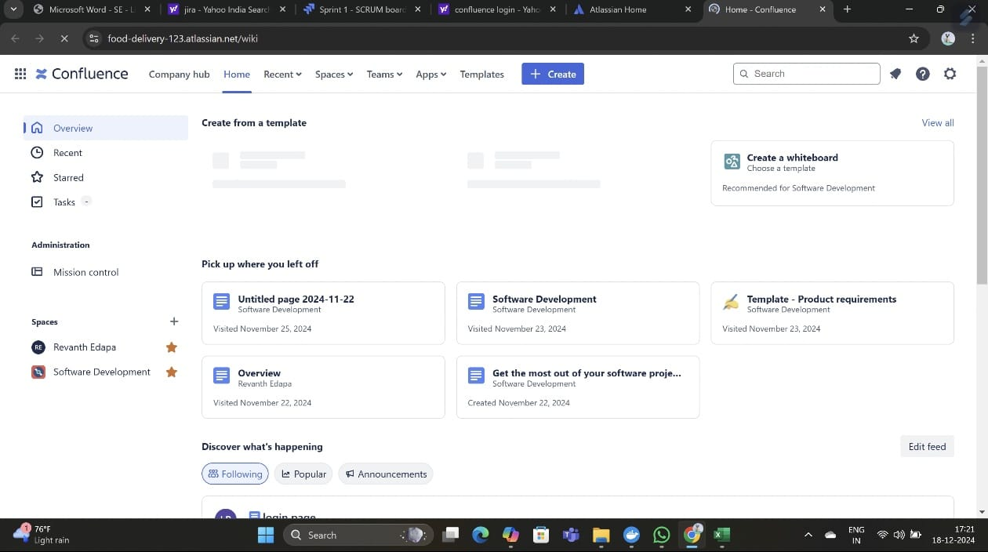

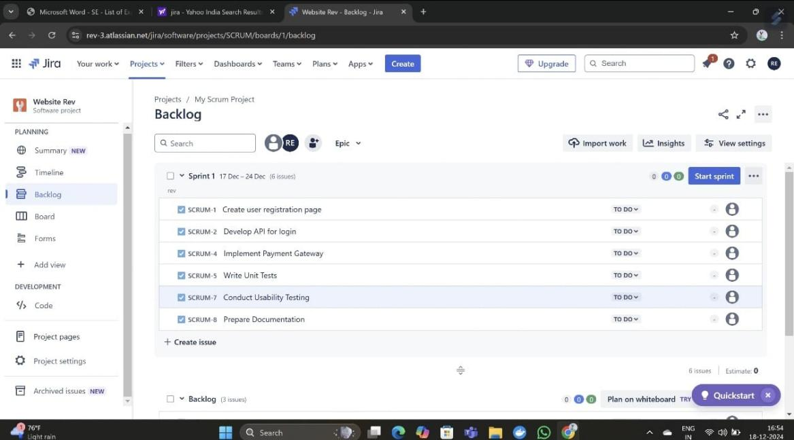

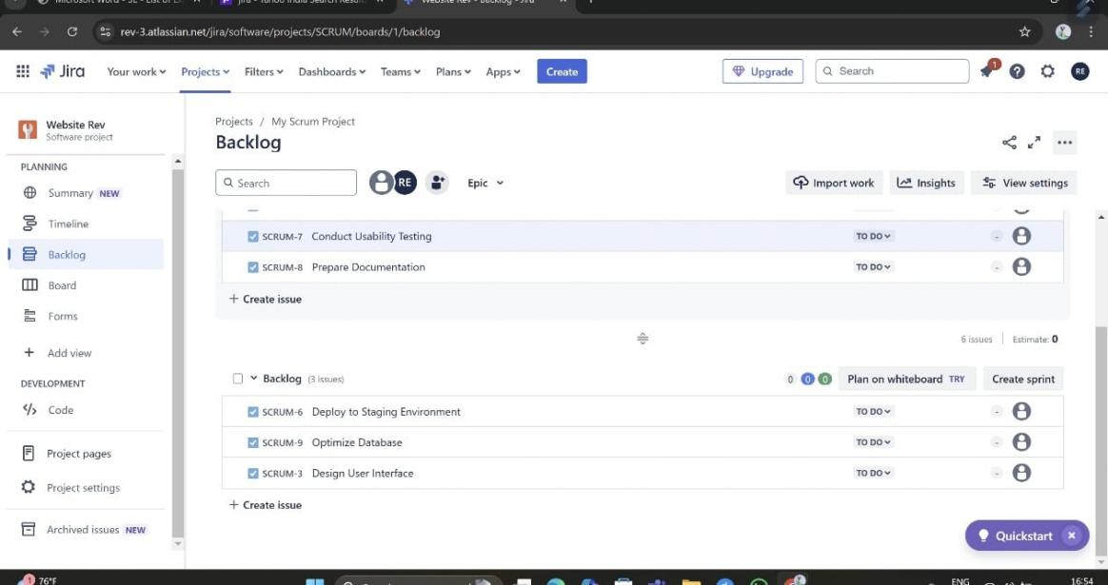

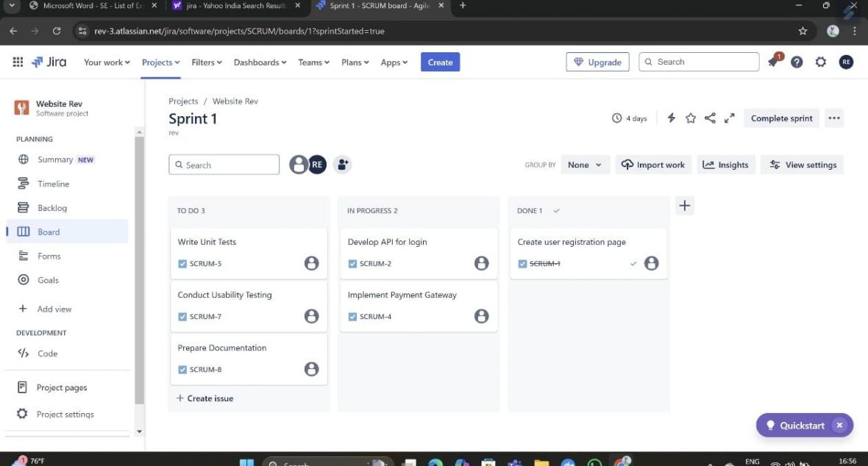

**5.** **Use the following requirements for a Library Management System:**

**∙ Add a feature to search books by title and author.**

**∙ Implement an online book reservation system.**

**∙ Generate monthly reports on borrowed books for**

**administrators.**

**∙ Enable email notifications for overdue books.**

**∙ Add support for QR code scanning for borrowing and**

**returning books.**

**∙ Create a user-friendly dashboard for librarians.**

**∙ Allow users to review and rate books.**

**∙ Integrate a chatbot for user assistance.**

**∙ Develop a mobile app version of the system.**

**∙ Provide multi-language support.**

**Categorize each requirement using MOSCOW Method (Must-Have,**

**Should-Have, Could-Have, or Won’t-Have) based on the following**

**criteria:**

**∙ Impact on the users and stakeholders.**

**∙ Feasibility considering time, budget, and resource constraints.**

**Finally Submit the completed Google Sheet or Excel file with all**

**requirements categorized and justified**

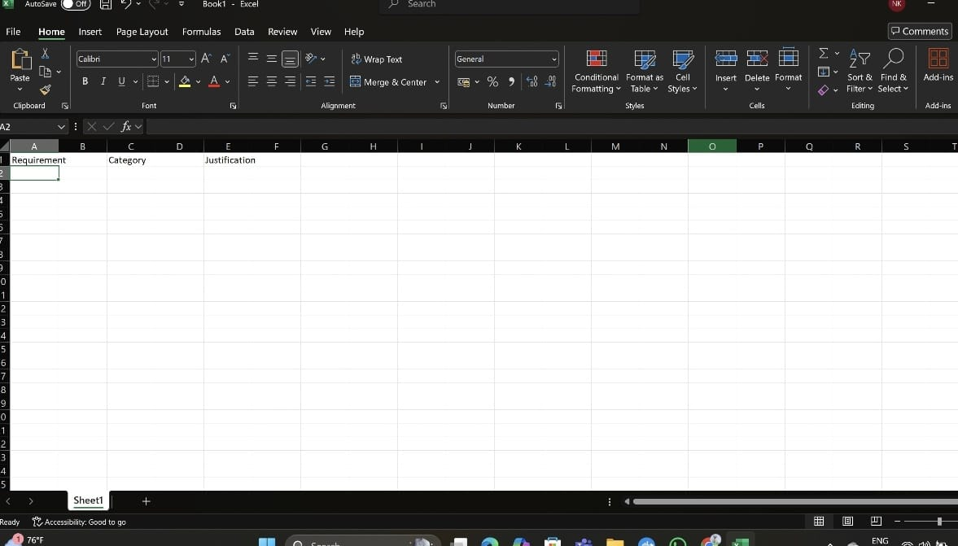

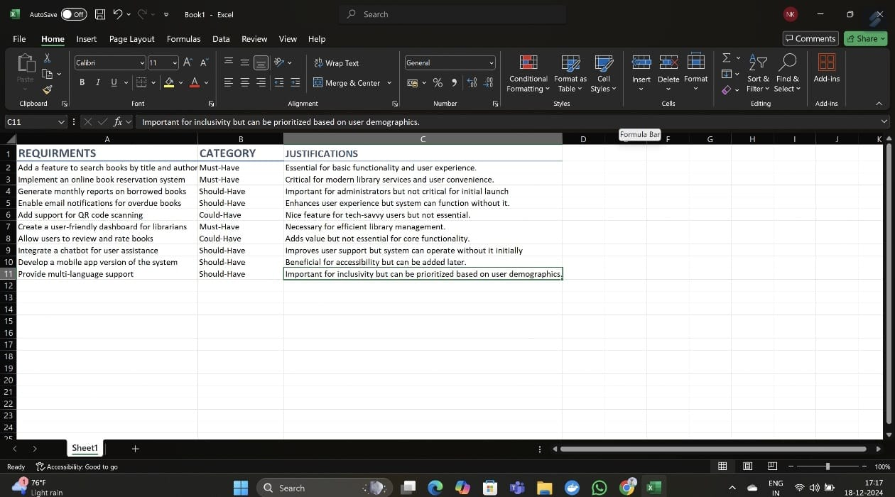

**6.** **Link Jira tasks with Confluence to streamline task tracking and**

**progress monitoring for the Library Management System**

**development.**

**∙ Create a new page in Confluence titled "Library Management**

**System Project Overview."**

**∙ Embed at least 5 Jira issues related to the development of the**

**Library Management System (e.g., tasks from the sprint like**

**"Develop book search functionality," "Create user login page,"**

**etc.).**

**∙ Use the Jira macro to display issues with status (e.g., "To Do,"**

**"In Progress," "Done").**

**∙ Add a progress bar in the Confluence page to visually track**

**the completion of each embedded Jira task (e.g., percentage of**

**tasks completed in the sprint).**

**∙ Submit a screenshot of the Confluence page showing the**

**embedded Jira tasks and the progress bar.**

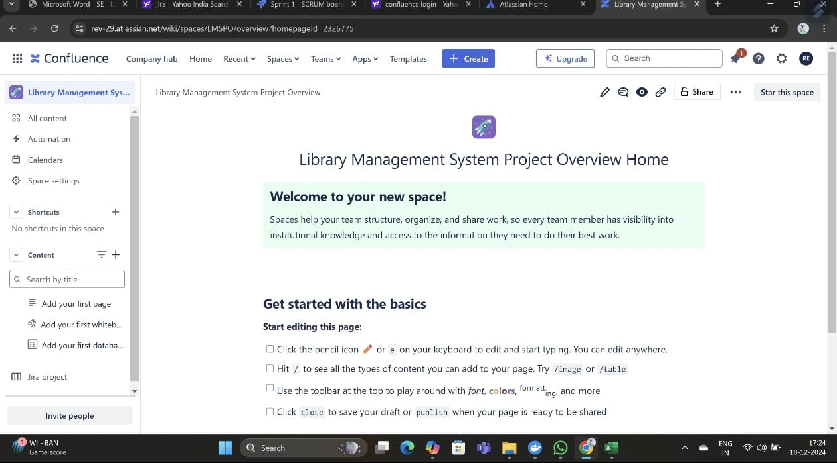

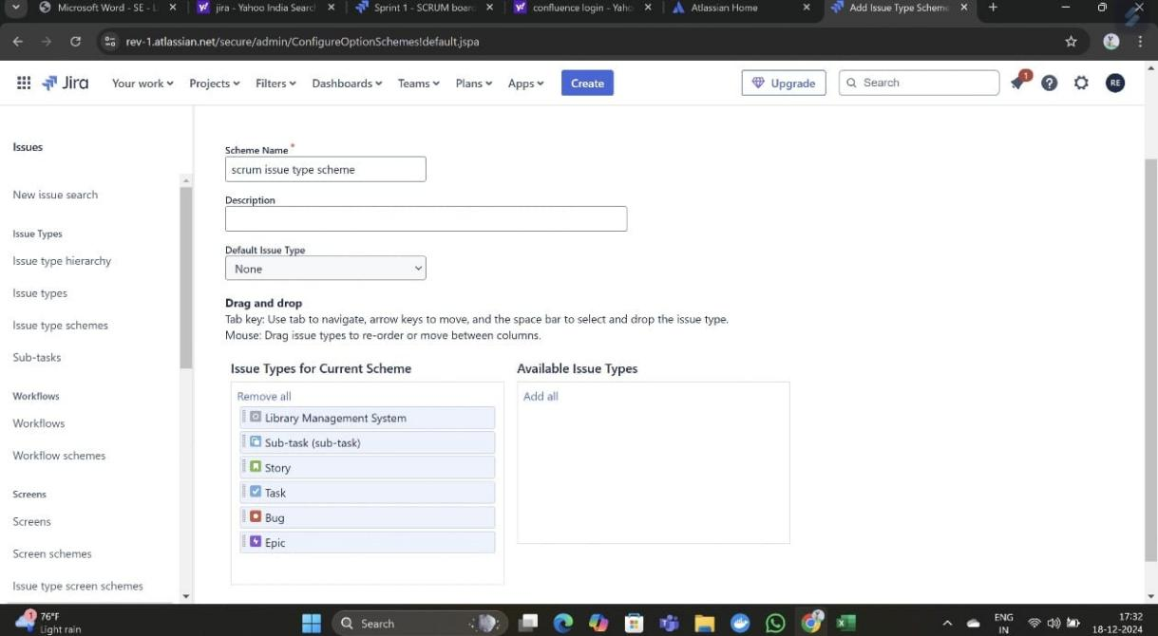

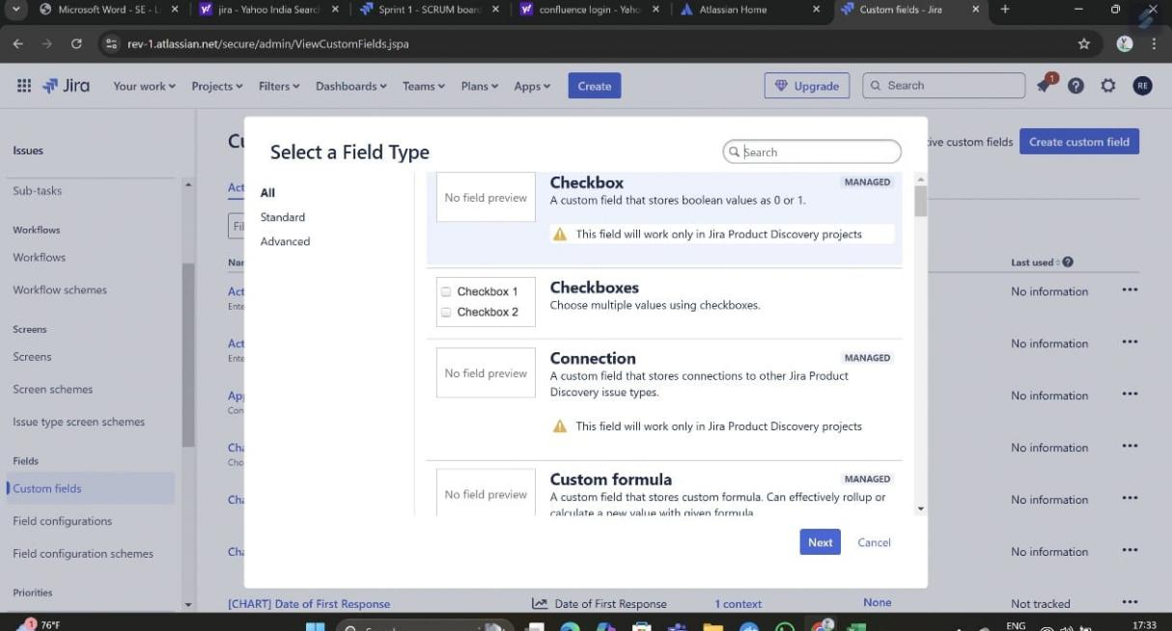

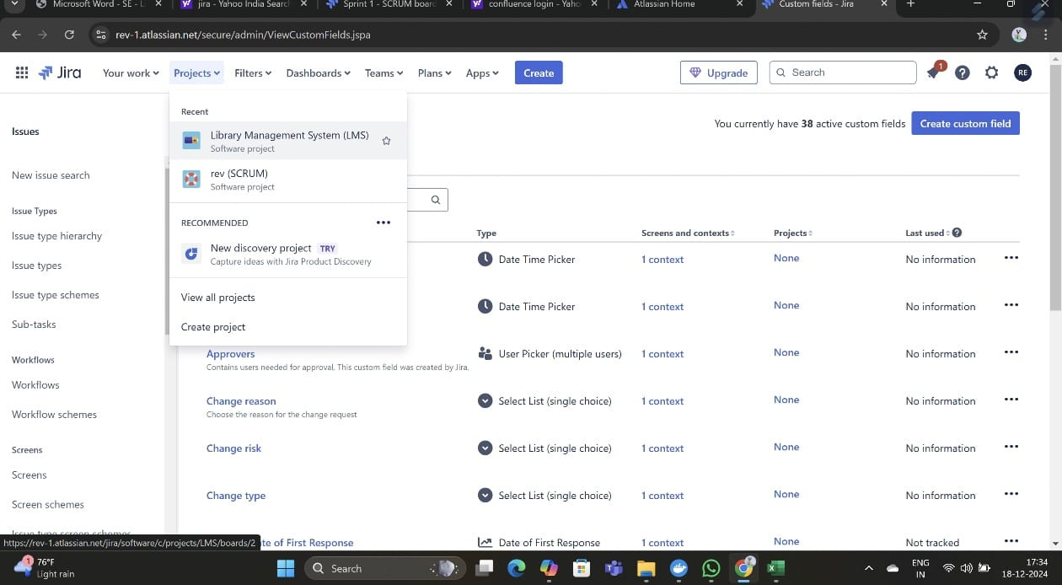

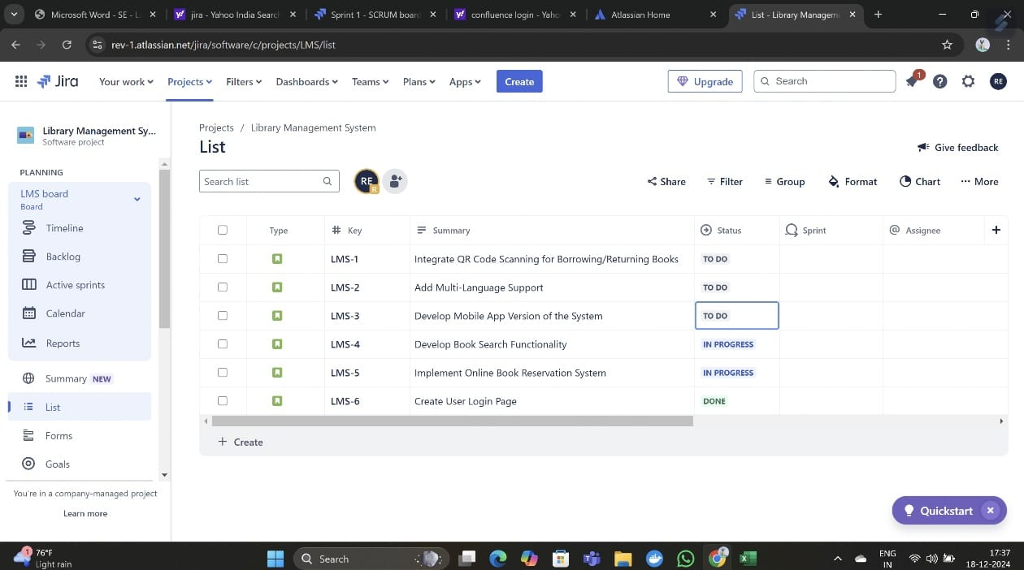

**6.You are designing a Task Management System for a small team. The**

**system should include the following features:**

**1.User Login and Role Assignment**

**2.Task Creation and Assignment**

**3.Task Prioritization and Deadlines**

**4.Progress Tracking and Reporting**

**Prioritize these requirements using the MoSCoW and Kano models in**

**Jira.**

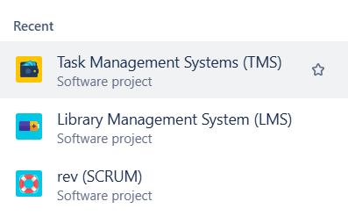

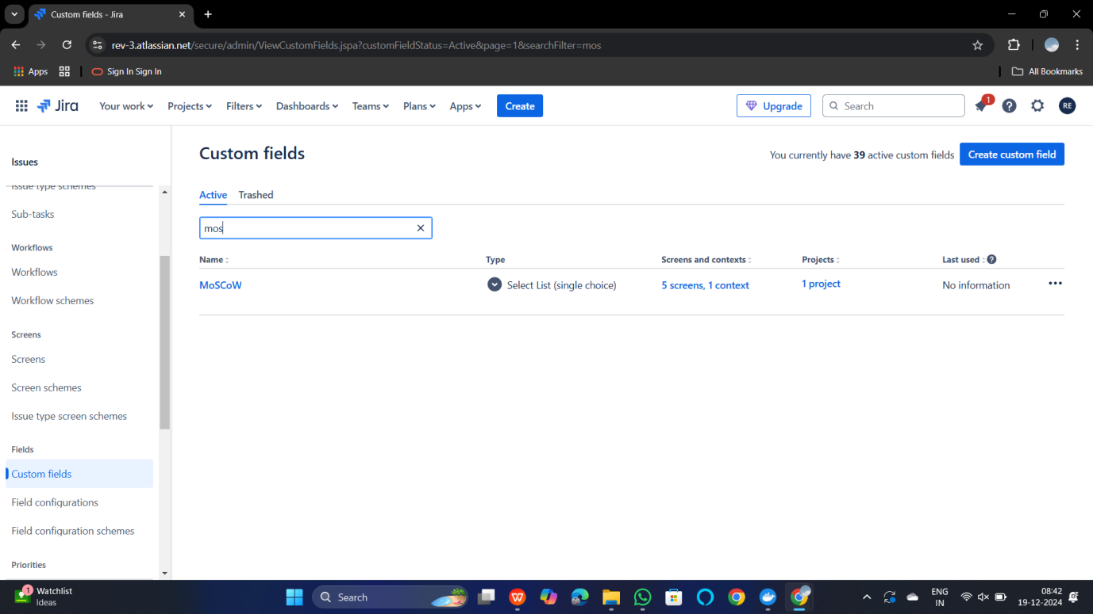

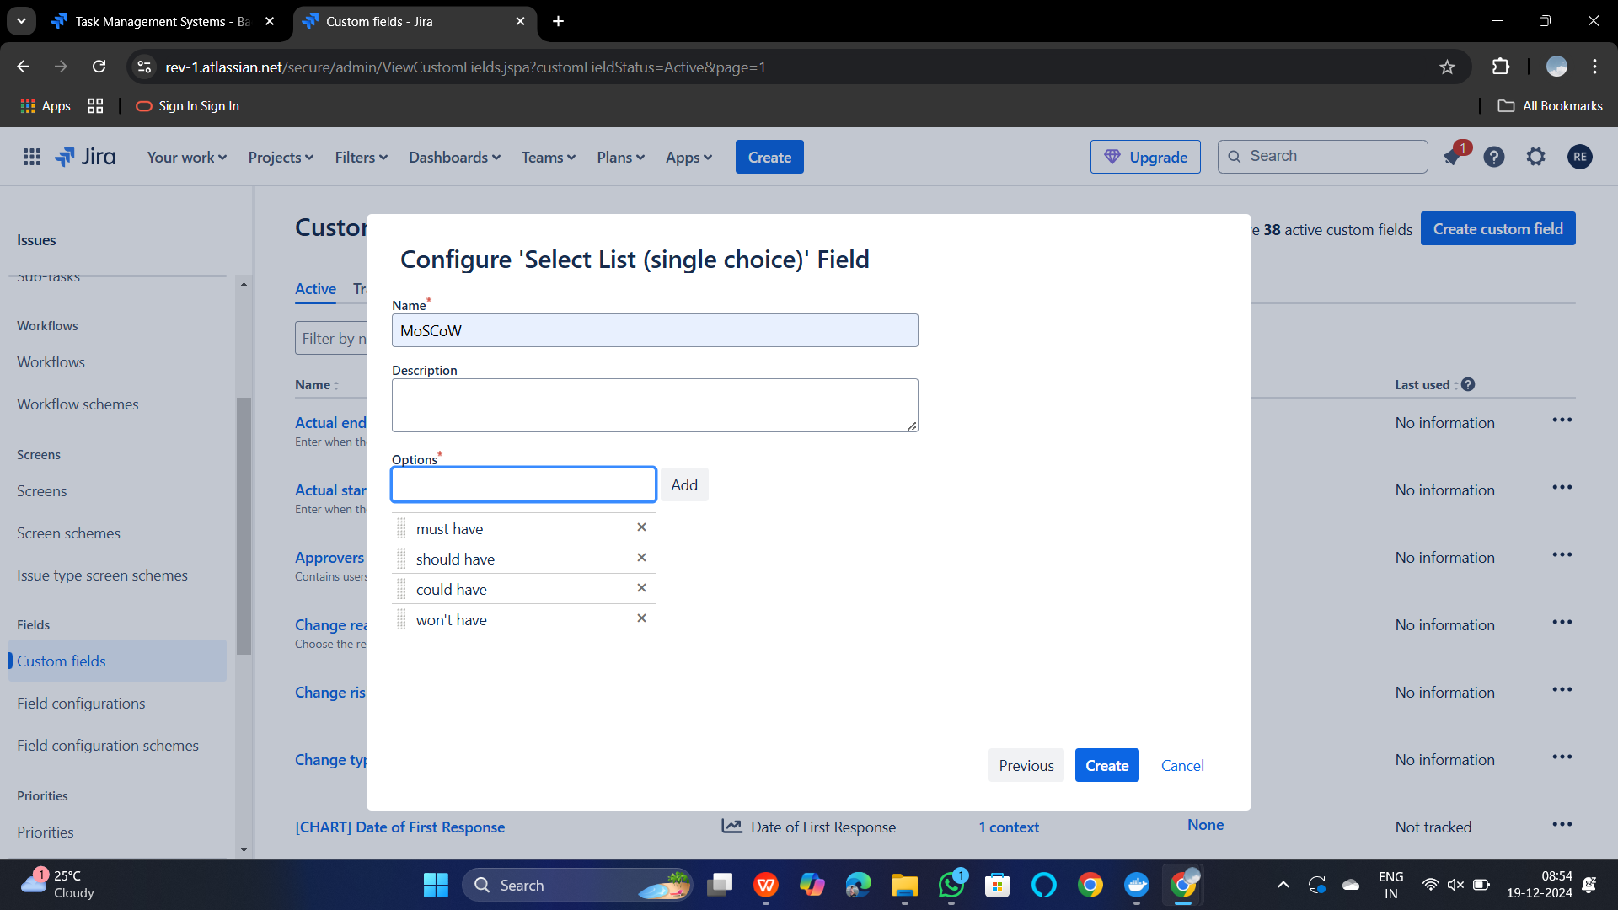

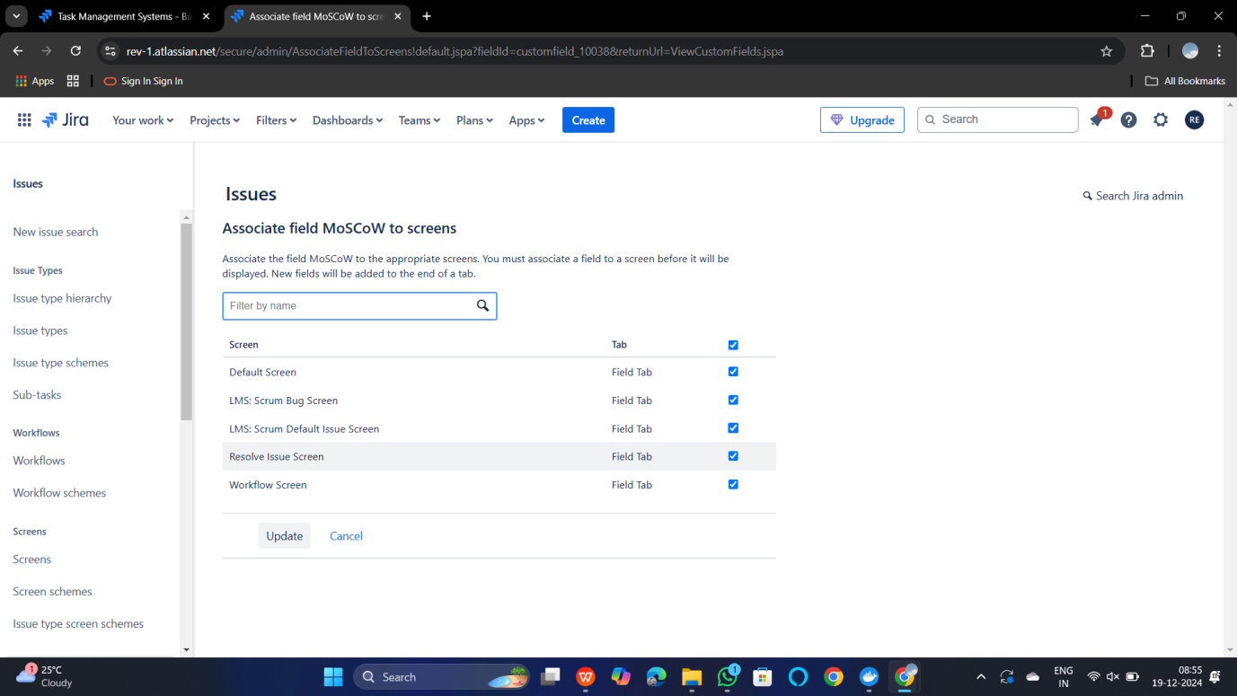

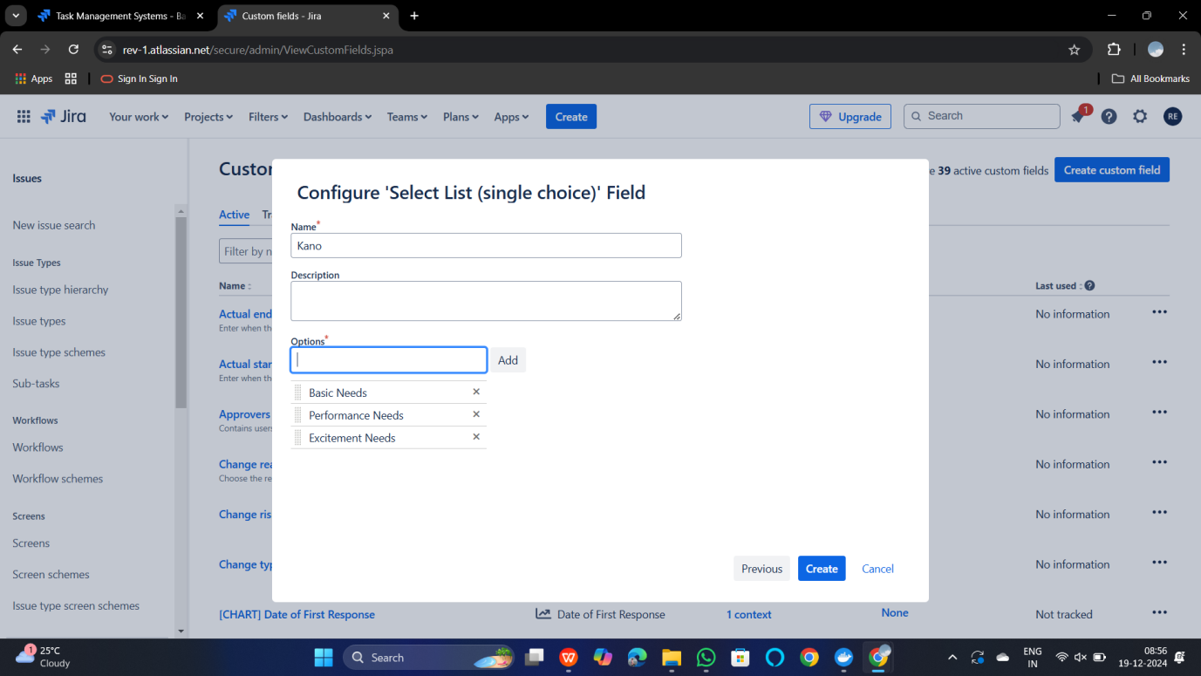



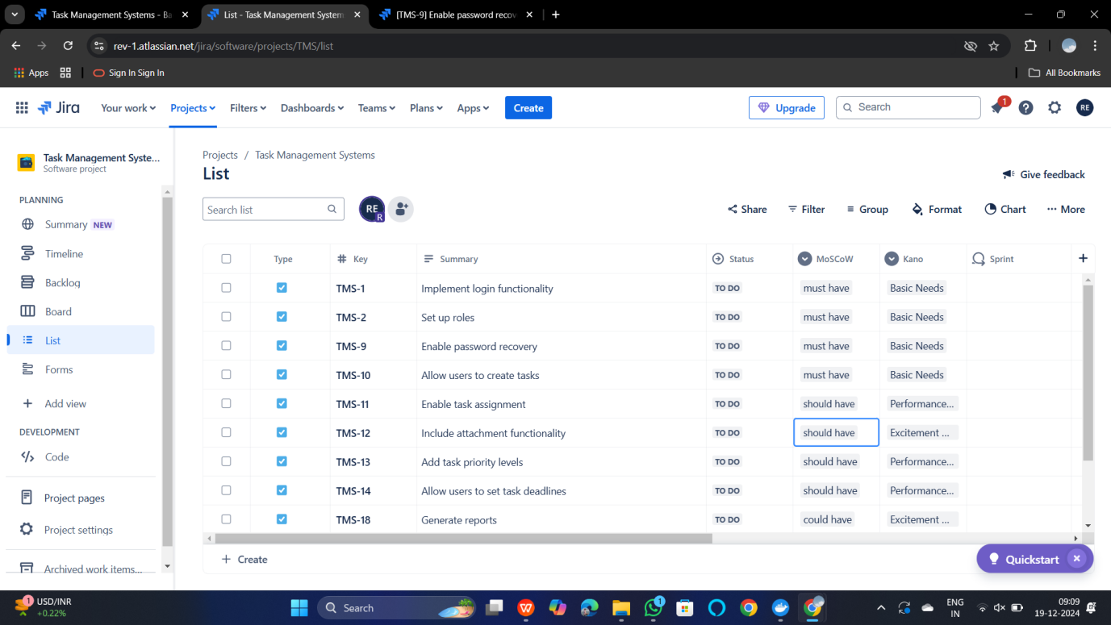

**8.You are tasked with developing an Online Learning Platform. The**

**platform should include the following functionalities:**

**1. Course Enrollment and Registration**

**2. Video Lecture Streaming**

**3. Interactive Quizzes and Assignments**

**4. Progress Tracking Dashboard**

**5. Peer-to-Peer Discussion Forums**

**6. Certificate Generation**

**Use Jira to categorize and prioritize these requirements using**

**MoSCoW and Kano techniques**

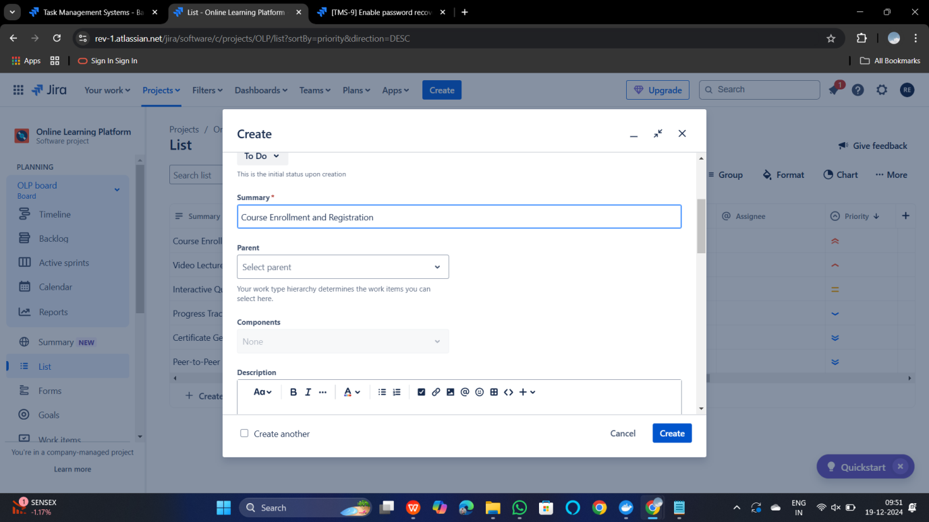

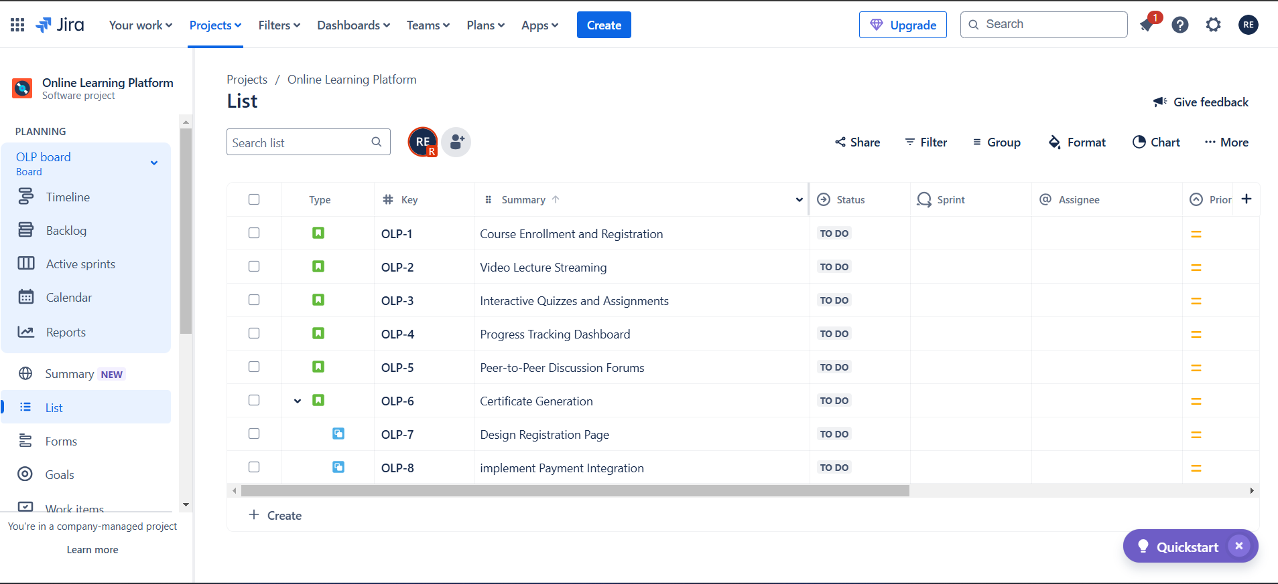

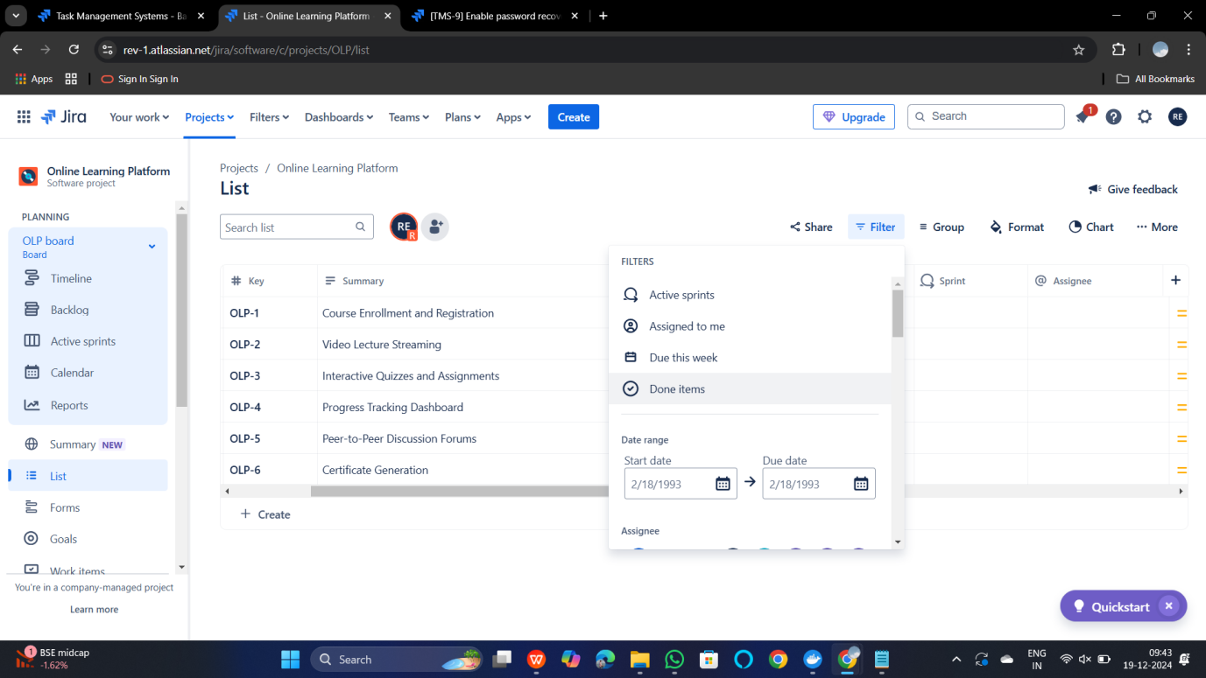

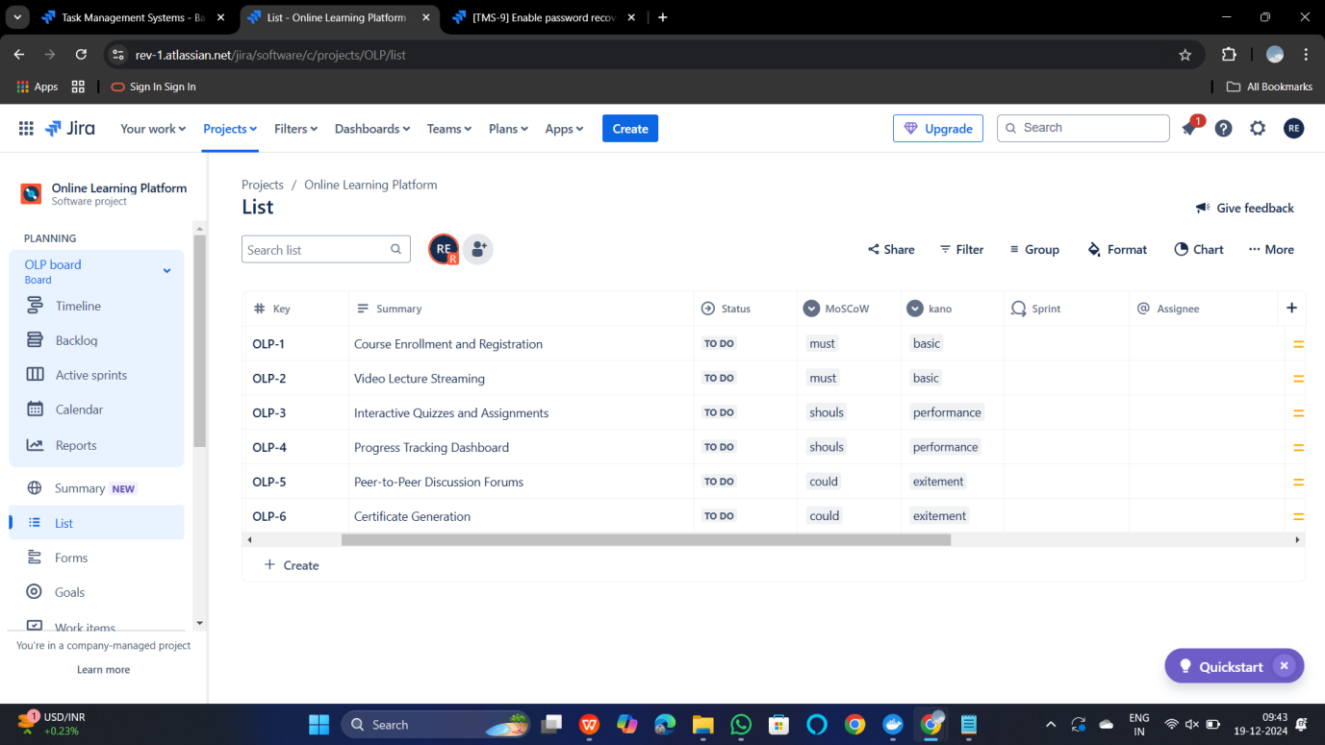

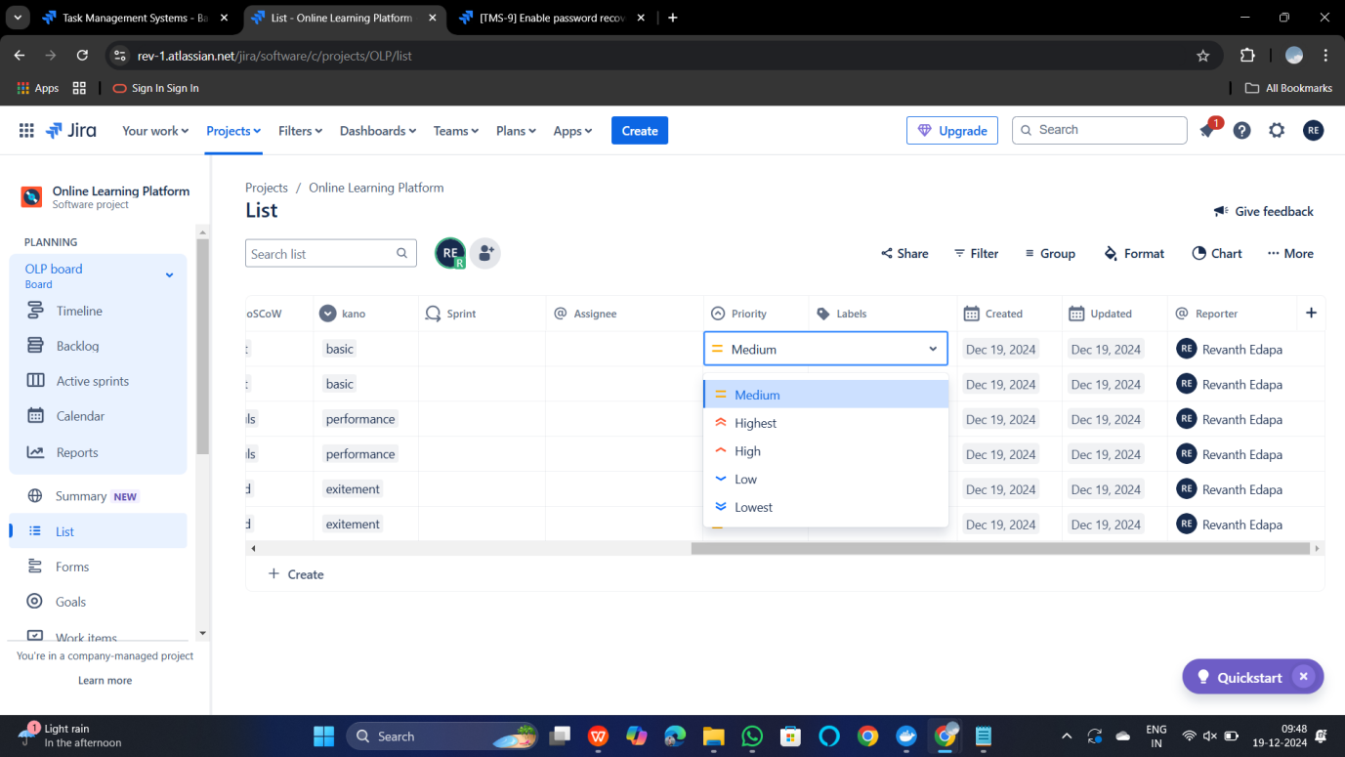

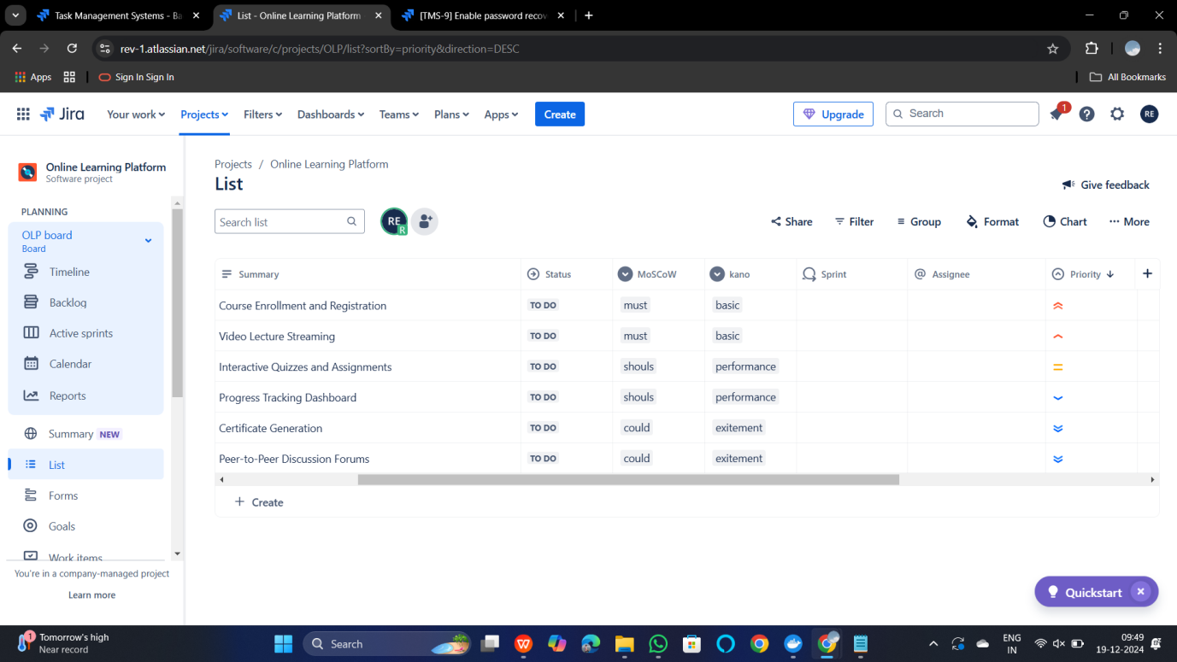

**11.** **Create a Static Website and Containerize, Build & Serve it using**

**Docker.**

**Tasks:**

**1. Create a Simple Static Website (index.html file) with basic**

**HTML content.**

1. **Write/create a Dockerfile to serve the website using Nginx.**

**3. Build the Docker Image**

**4. Run the container:**

**5. Access the Website using a Browser**

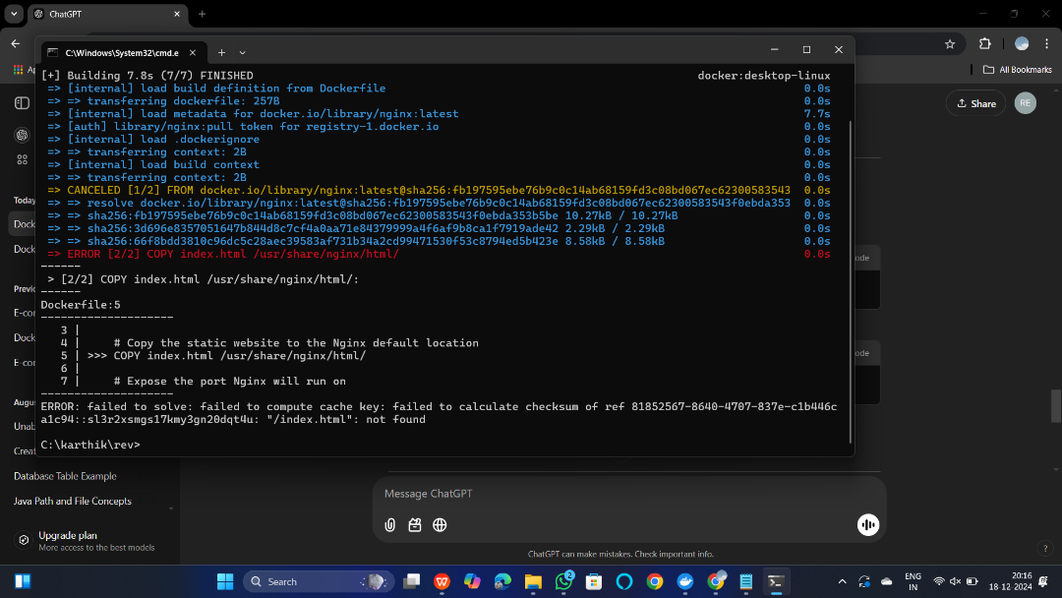

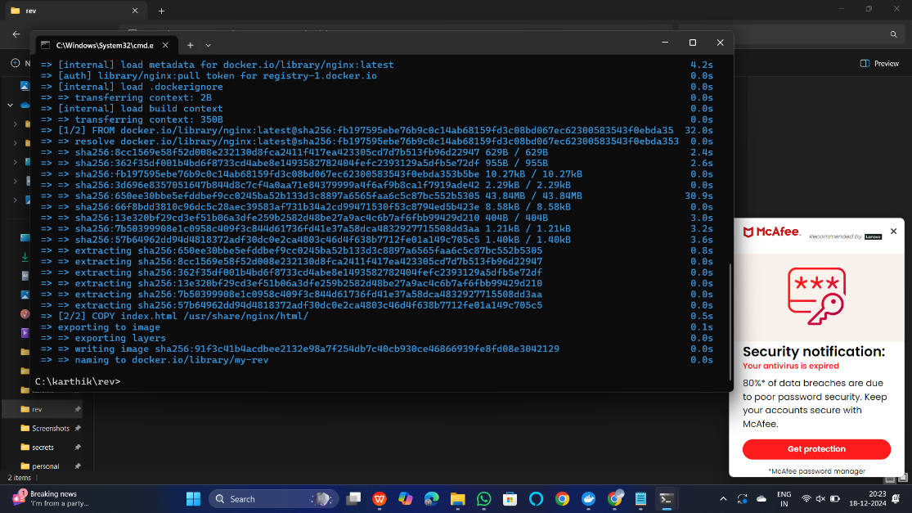

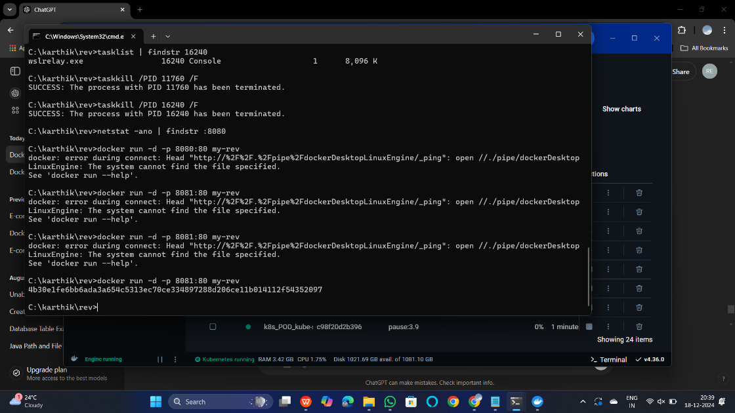

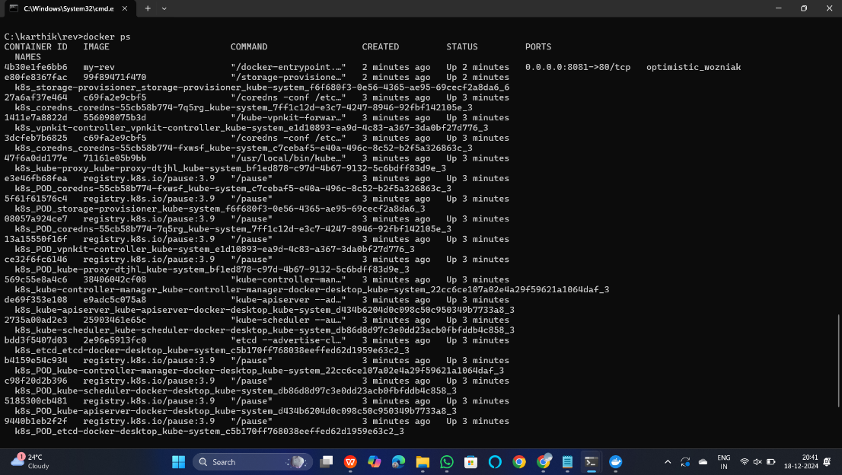

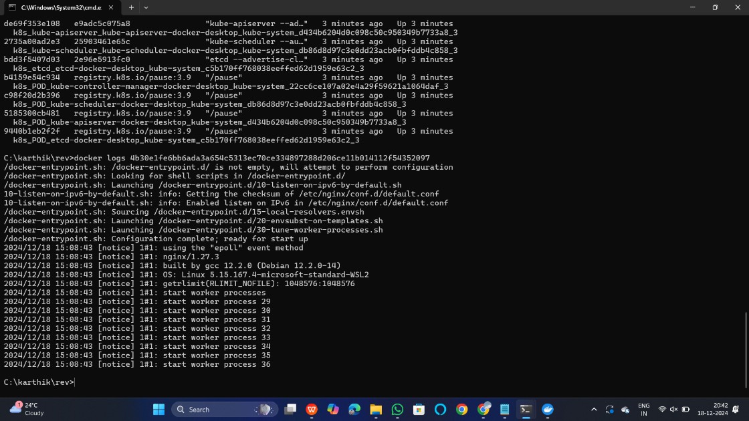

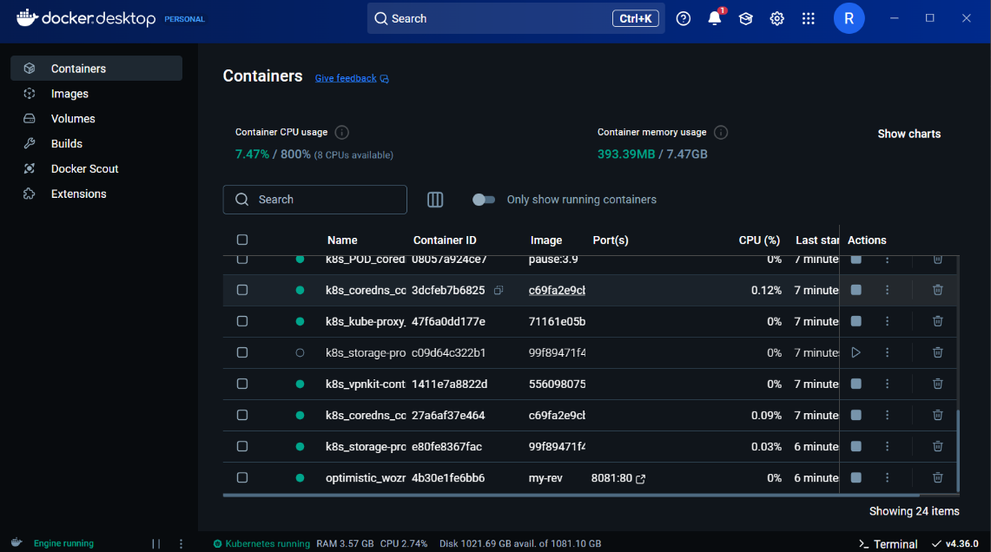

**15.Create a GitHub Repository and Implement Version Control**

**Tasks:**

**• Set up a repository for a team project.**

**• Create branches for individual modules.**

**• Merge branches with pull requests after code reviews.**

**• Resolve conflicts during branch merging.**

**• Document the workflow using the README file.**

**• Submit the repository link.**

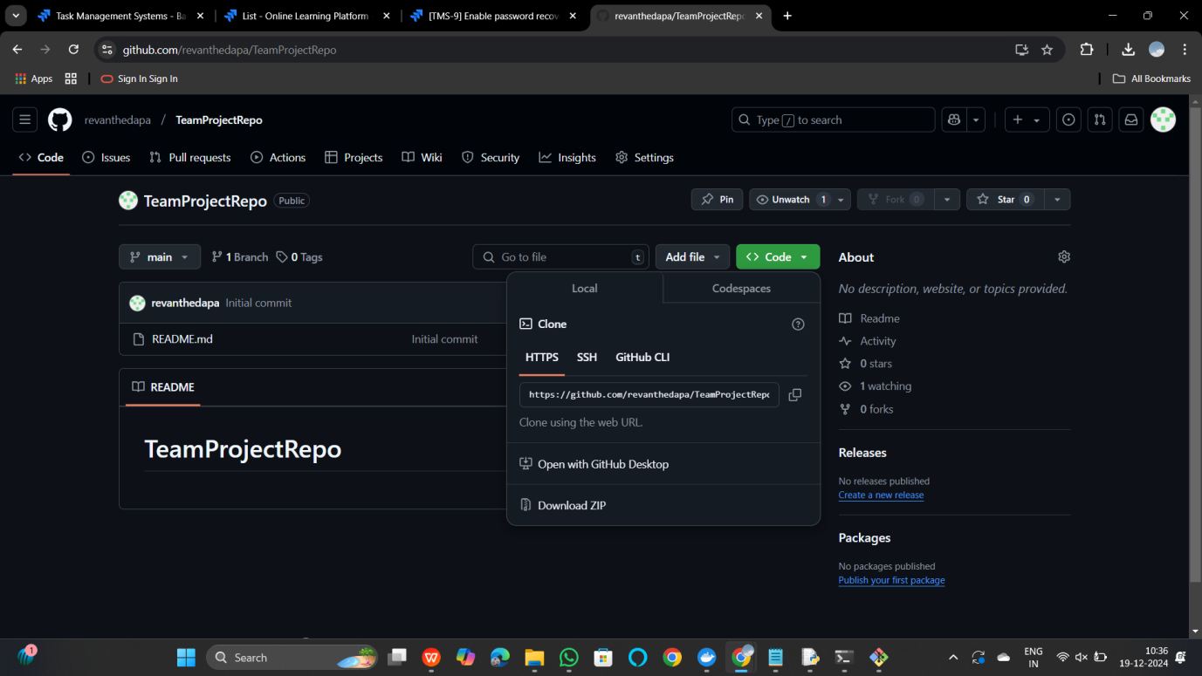

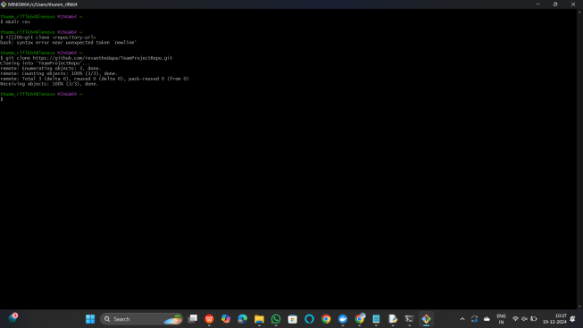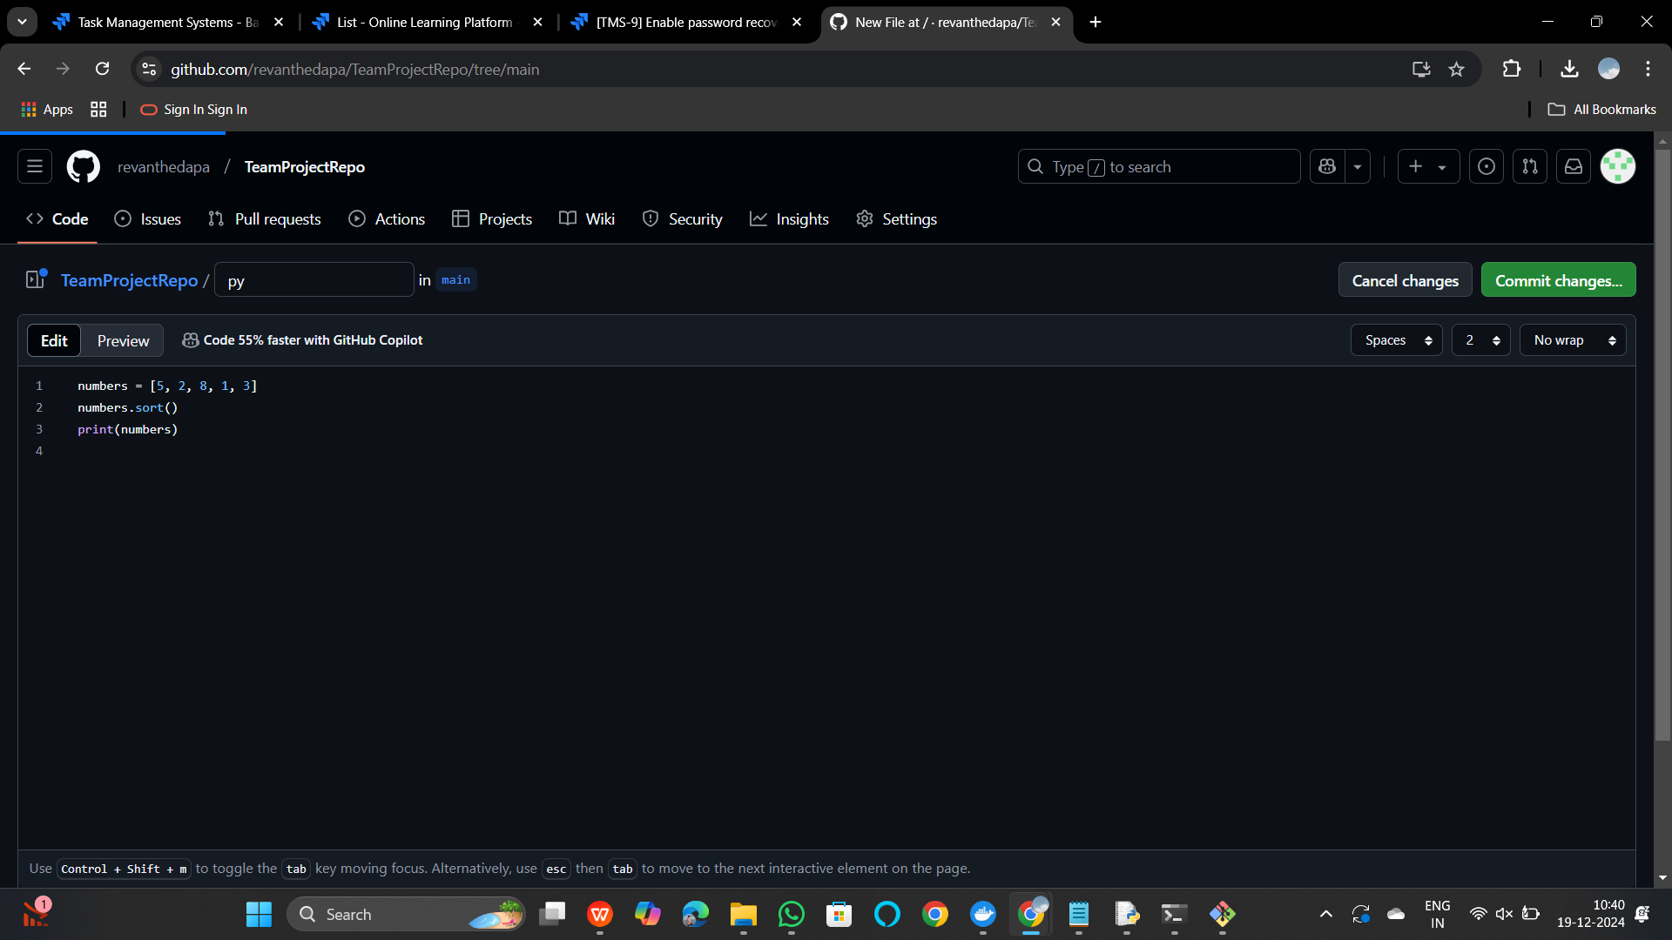

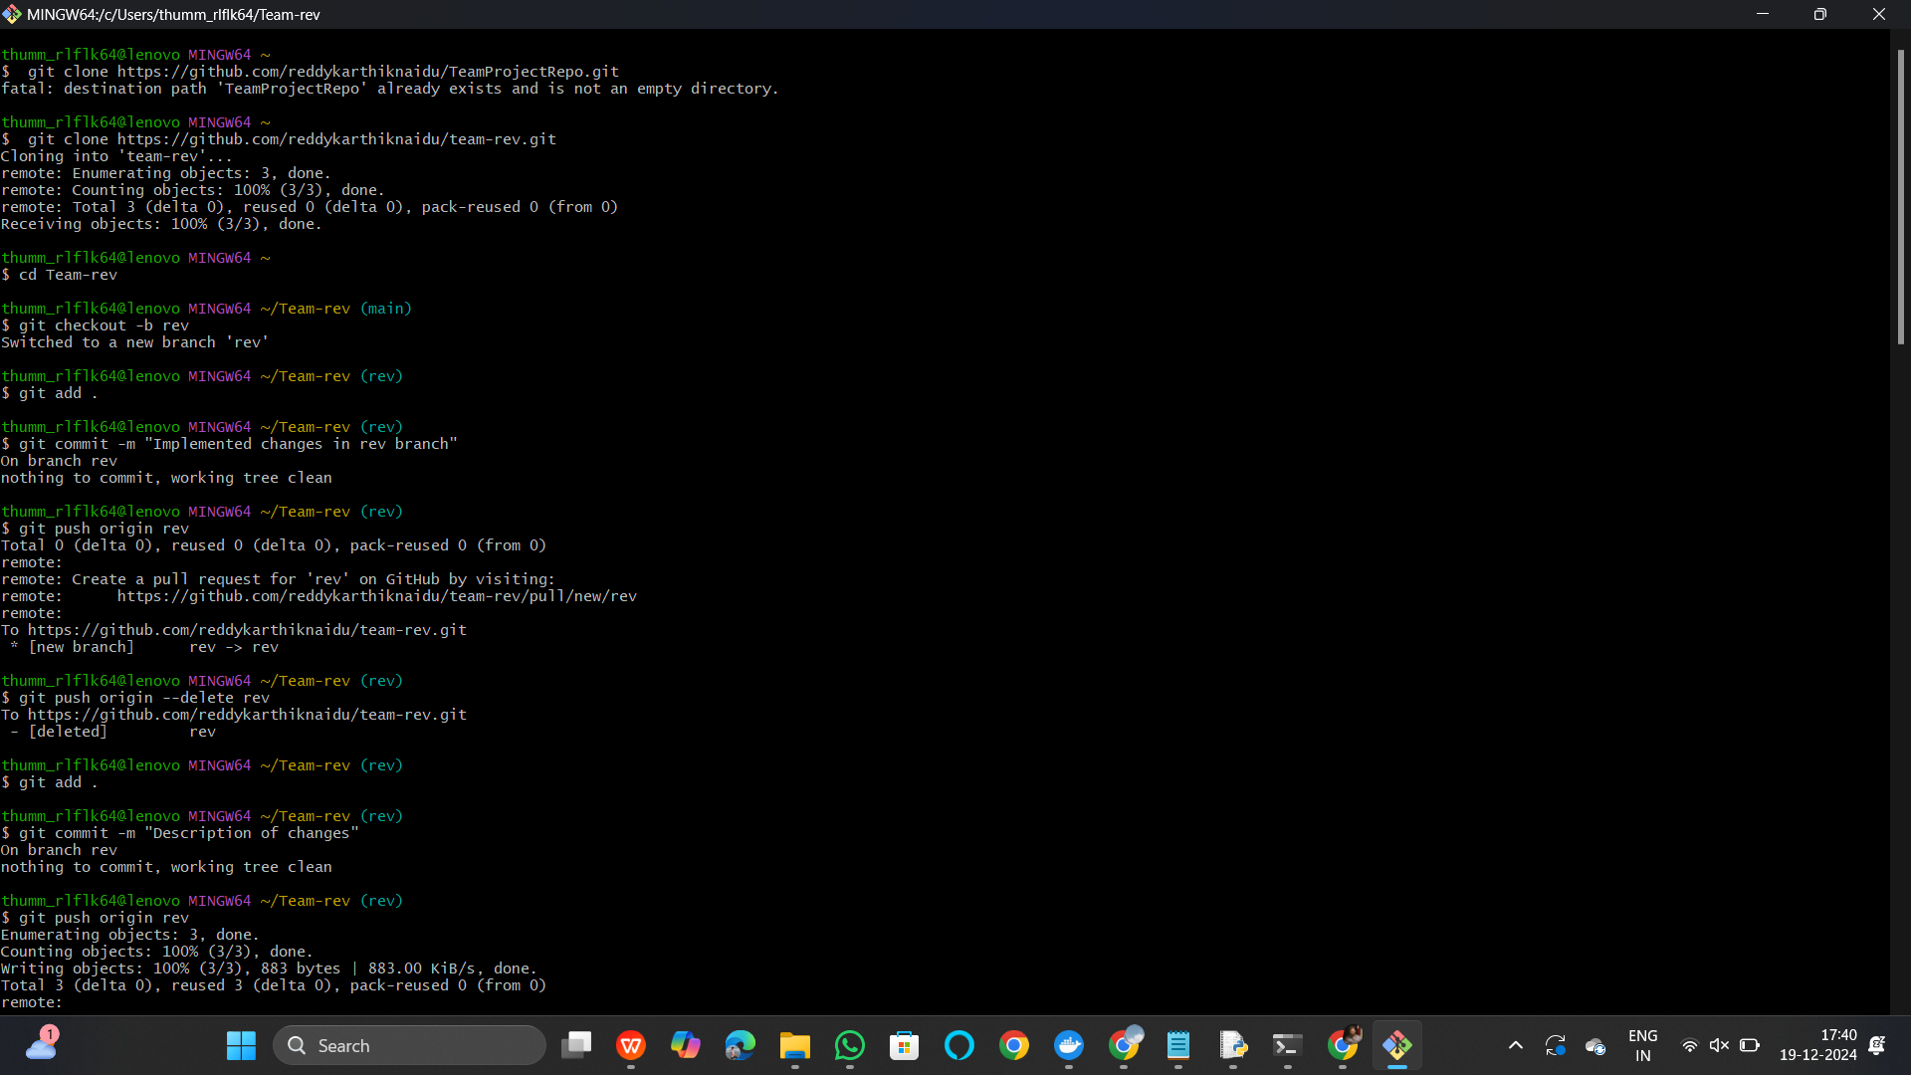

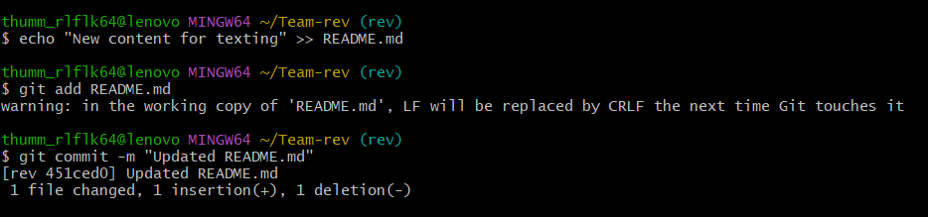

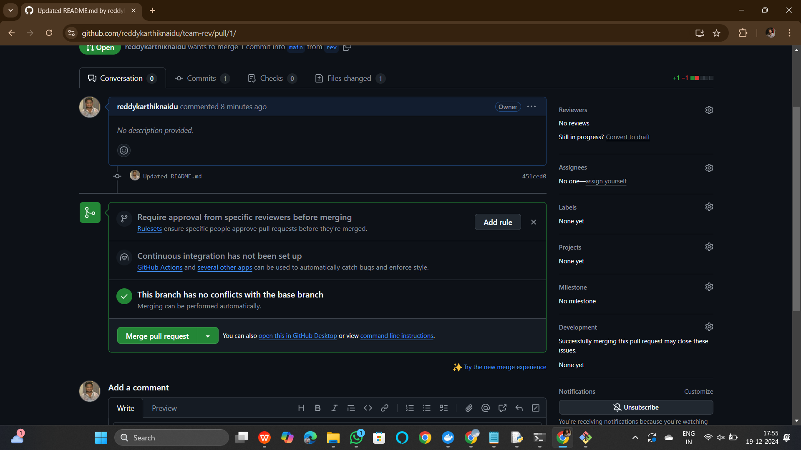



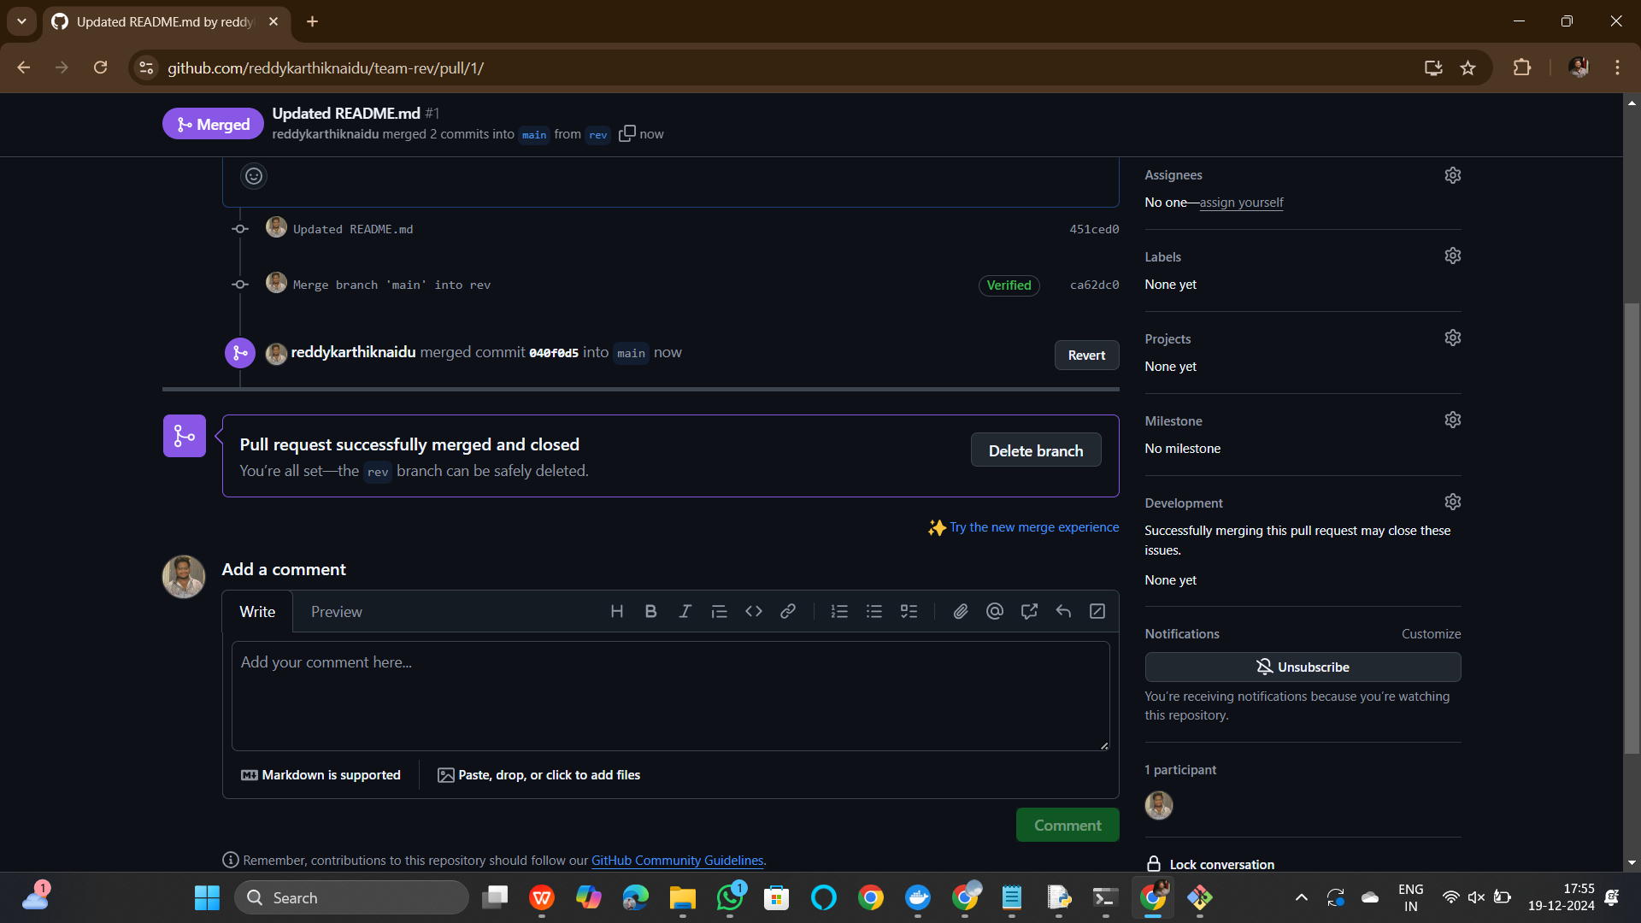

**End.**